CHAPTER 3 - PROGRAMS AND SERVICES

CHAPTER 3
PROGRAMS AND SERVICES
INSTRUCTION
Library & Media Services
Division

MT. SAN ANTONIO COMMUNITY COLLEGE DISTRICT EDUCATIONAL MASTER PLAN - Page 223

CHAPTER 3 - PROGRAMS AND SERVICES

LIBRARY & MEDIA SERVICES
Meghan Chen, Dean, Library & Learning Resources
Emily Woolery, Department Chair

CURRENT SERVICES
Within Library & Media Services, services include:
• Library: the operation and administration of traditional library services. Annually the Library has the following number of contacts:
399,233 with students and 880 with staff.
• Media Services: media collection for faculty use, listening rooms for students, and equipment for non-equipped campus classrooms.
Media Services provides service to approximately 1,200 students annually and makes 24,000 visits or deliveries per year to
staff/classrooms.
• Library (Academic): instructional/academic component offering LIBR 1, 1A, and 1B classes to meet the transfer and general interest
needs of students. Approximately 275 information competency instruction sessions are conducted each year.

ENROLLMENT
Academic Library class sizes range from 12 to 20 students and the average lecture class size is 19. There are presently no waiting lists for
classes.

FACILITIES
• Library: Located in Bldg. 6, the 46,328 sq. ft. Library does not currently have adequate study space. The upcoming bond measure
includes money for a new 50,000 sq. ft. Library & Learning Resources building adjacent to Bldg. 26 A, B, D. Current needs include
updating the Library Management System (SIRSI) and additional study rooms.
• Media Services: Three listening rooms in the current Library that are not adequate. Ten listening rooms are needed and are included
in plans for a new Library facility. More equipment is needed now to install in classrooms; with equipment in classrooms, the number
of equipment deliveries to classrooms would be reduced.
• Library (Academic): One classroom is located in Bldg. 6. It lacks adequate space and is not set up for computers. Laptops are used,
but they do not regularly work.
TEACHING METHODOLOGIES
Instruction sessions are 100% lecture.

PERSONNEL
Division personnel include a manager, 15 full-time classified staff, 9 FTE (47.5%) part-time classified staff, 2 student workers, 6 FTEF full-
time faculty, and 5 FTEF part-time faculty. Three additional full-time classified staff members and four full-time faculty are needed now.

FUTURE PLANS
• Library: As the student population grows, additional support staff will be needed along with more study space to accommodate
students. Online services will continue to be provided whenever possible, but students will still need one-on-one assistance.
• Media Services: New techniques and flexibility for delivery of media to classrooms will be needed in the future; for example, Media
Services wants to develop a subscription service.
• Library (Academic): one class section is anticipated to grow to two sections; growth of Distance Learning will affect the expansion of
courses.

ENROLLMENT
Department enrollment is expected to grow more slowly than the District’s enrollment overall through 2020.
FACILITIES
• Library: Future facility needs for the Library largely hinge on the bond measure outcome which includes a larger, new building for the
Library & Learning Resources Division by 2014. On an ongoing basis through 2020, there is a need to continue to update the Library
Management System (SIRSI) and increase study rooms.
• Media Services: Also contingent on the bond measure, a new Media Services Center (with 10 study/listening rooms) within the
Library/Learning Center will be opened by 2014. A constant, future goal is to have every classroom on campus equipped with

MT. SAN ANTONIO COMMUNITY COLLEGE DISTRICT EDUCATIONAL MASTER PLAN - Page 224
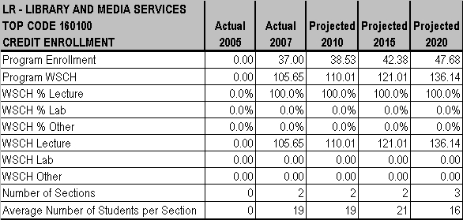
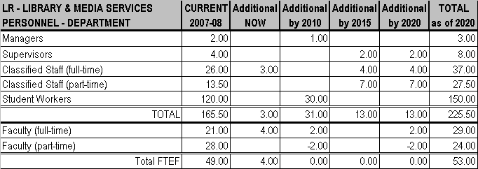

CHAPTER 3 - PROGRAMS AND SERVICES

appropriate media. Even when this is achieved, upgrading and/or replacing existing equipment will be an ongoing process through
2020.
• Library (Academic): Facility needs include a computer classroom by 2015, which will be included in the new Library building if the
bond measure passes. Also, every three years between now through 2020, updating computer equipment will be required.
TEACHING METHODOLOGIES
No change in teaching methods is anticipated at this time.

PERSONNEL
The Division will need 1 additional manager, 30 more student workers, and then decreasing part-time faculty FTEF by 2 persons, but increasing full-time faculty FTEF personnel by 2 members by 2010. By 2015, 2 additional supervisors, 4 full-time classified staff, and 7 part-time classified staff FTE will be needed. By 2020, again 2 supervisors, 4 full-time classified staff, 7 part-time classified staff FTE will need to be added, plus reducing part-time faculty FTEF by 2 persons, but increasing full-time faculty FTEF by 2 members.

MT. SAN ANTONIO COMMUNITY COLLEGE DISTRICT EDUCATIONAL MASTER PLAN - Page 225
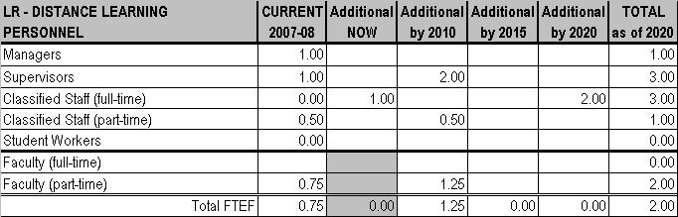

CHAPTER 3 - PROGRAMS AND SERVICES

DISTANCE LEARNING
Meghan Chen, Dean, Library & Learning Resources

CURRENT SERVICES
Responsibilities of Distance Learning include providing equipment, software, and support staff for the campus-wide online learning and related technologies. Currently, the department handles the following number of contacts annually: 1,100 students; 386 staff; 88 public. There is no waiting period for students; problems are resolved immediately. Faculty training is conducted by appointment. The department acknowledges that students are requesting more service and that additional training is needed in these areas: online learning strategies and techniques; course design; effective communication strategies; and multi-media applications.
FACILITIES
Distance Learning is currently housed in Bldg. 6. Facilities include an office/mentoring area in Room 262 and a classroom/lab/meeting
room in Room 261. In addition to continued support by the campus for appropriate technology and equipment for faculty, an expansion of software (i.e., Blackboard Communications) with adequate space for servers and storage are needed now.
PERSONNEL
Current personnel for Distance Learning includes a manager (who also manages Library & Media Services), a coordinator, 0.5 part-time classified staff, and 1.2 part-time faculty. One additional full-time classified staff employee is needed now.

FUTURE PLANS
Between 2006-07 and 2007-08, the program grew by 27.5% due to increased interest in the program and there is great potential for
constant and evolutionary growth in online learning in the future. The Blackboard Enterprise System is currently used for course
management; however, it is difficult to anticipate what type of delivery system will be used in the future as the industry is in constant flux. As new technologies and delivery systems become available, the program expects to see a shift toward synchronous online learning. Indications are that the program will be widely adopted throughout the Distrct and become part of the regular delivery system of courses. Additional support staff and faculty mentors will be needed to grow the program.

FACILITIES
By 2010, Distance Leaning will need additional server space, preferably located with Information Technology (IT). By 2015, an additional
multimedia development lab adjacent to the Online Learning Support Center will be needed. On an on-going basis between now through
2020, there will be a continued need for growth of servers and storage, expansion of software, and appropriate technology and equipment
support for faculty.

PERSONNEL
By 2010, 2 full-time classified staff, 0.5 part-time classified staff, and 1.25 part-time faculty FTEF will be needed. By 2020, Distance Learning will need 2 additional full-time classified staff members.

MT. SAN ANTONIO COMMUNITY COLLEGE DISTRICT EDUCATIONAL MASTER PLAN - Page 226

CHAPTER 3 - PROGRAMS AND SERVICES

LEARNING ASSISTANCE CENTER (LAC)
Meghan Chen Dean, Library & Learning Resources
Pat Bower, Department Chair

CURRENT SERVICES
The Learning Assistance Center (LAC) provides four services:
• Learning Lab: a computer facility for student work on credit and non-credit curriculum-based learning. This service area has contact
with 12,436 students and 25 members of the public annually. There can be a wait of 15 to 20 minutes for students to register, sign in,
and sign out.
• Skills Lab: tutoring for curriculum-based assignments for students enrolled in skills-level courses in reading, writing, and mathematics.
Services are provided to 13,167 students annually.
• Testing Services: a 22-seat room for students taking exams outside the classroom, including students enrolled in traditional courses,
distance learning courses. A total of 7,547 exams are currently given annually.
• Tutorial Services: a multi-subject drop-in tutoring center serving students enrolled in pre-collegiate through transfer level courses. This
service has contact with 9,760 students annually. During peak times (9 a.m. to 2 p.m.) there is a waiting period for service of 30 to 60
minutes. Classes serve the transfer, occupational, and general interest needs of students.
ENROLLMENT
• READ 70, 80, 90, and 100: class sizes range from 22 to 36 students (with 24 students in pre-collegiate sections). Average class size
is 25 students for lecture. There are currently waiting lists of 5 to 10 students per class (maximum size allowed for waiting lists is 10
students).
• STDY 80, 85 and 100: class sizes range from 22 to 30 students; average class size is 25 students.
• LERN 81: class sizes range from 18 to 30 students, although the curriculum limit is 20 students. Average class sizes are 25 students.
Current waiting lists number 2 to 5 students.
• TUTR 10 A-D: class sizes range from 10 to 15. One unit classes are offered with 2 or 3 sections per semester. Average lecture class
size is 12 students. There are currently no waiting lists.
• LERN 48 & 49: class sizes range from 25 to 35 students (class limit should be 24 students) and it is typical to offer 54 sections.
Average class size is 28 students. Current waiting lists number 10 students for both LERN 48 and LERN 49.
• LERN 61 & 62: class sizes range from 8 to 15 students and the average lab class size is 10 students. There are no waiting lists.
FACILITIES
The current facility is located at the west side of campus while the new/renovated buildings are at the center or east side of campus. If the bond measure passes, all LAC/LLR facilities and services will be centrally located.
• Learning Lab has an open lab. It lacks security and needs its own doors/gate.
• Skills Lab has an open lab. There are insufficient desks/tables to support pedagogy.
• Testing Services has a testing room, but there are insufficient seats for test takers during peak exam times during semesters.
• Tutorial Services has an open lab and study groups. The facilities lack study rooms; 15 to 20 rooms are needed. Classroom facilities include:
• READ 70, 80, 90, 100: 4 classrooms and lab in LTC (Bldg. 6)
• STDY 80, 85, 100: 2 classrooms in LTC (Bldg. 6)
• LERN 81: 2 classrooms in LTC (Bldg. 6)
• TUTR 10 A - D: 1classroom in LTC (Bldg. 6)
• LERN 48 & 49: 3 classrooms in LTC (Bldg. 6)
• LERN 61 & 62: an open lab in LTC (Bldg. 6)
TEACHING METHODOLOGIES
Online tutoring has not been offered to date due to regulatory disallowance for the collection of apportionment (which changed in January 2007) and insufficient staffing and training; however, a pilot program will begin in Fall 2008 for select distance learning courses.
• READ 70, 80, 90, and 100: lecture (20%) and project-based and collaborative (80%). READ 70 & 80 use lab methods only outside of
class for assignments.
• STDY 80, 85 and 100: lecture (20%) and project-based and collaborative methods (80%).
• LERN 81: lecture (25%) and computer-based assignments (75%) which are both project-based and collaborative. Lab is outside class
and students do not earn credit.
• TUTR 10 A-D: 20% lecture and 80% case studies/presentation/collaboration.

MT. SAN ANTONIO COMMUNITY COLLEGE DISTRICT EDUCATIONAL MASTER PLAN - Page 227

CHAPTER 3 - PROGRAMS AND SERVICES

• LERN 48 & 49: 40% lecture, 60% project-based and collaborative.
• LERN 61 & 62/Skills Development: 100% one-on-one.
PERSONNEL
Current LAC personnel include 1 manager, 1 coordinator, 11 full-time classified staff, 14 part-time classified staff, 80 student workers, 15
full-time faculty FTEF, and 33 part-time faculty FTEF. An additional 2 full-time classified staff and 4 full-time faculty FTEF are needed now.

FUTURE PLANS
Increased enrollment is anticipated to affect the LAC in several ways:
• An estimated 25% increase in enrollment in Math (LERN 48 and LERN 49) will result in the need for at least 3 to 4 additional classes
per year to accommodate the estimated 500 additional students. This will call for more faculty, more classroom space, and more
tutors.
• Increased demand for extended hours will require more permanent staff to cover expanded hours.
• Increased demand for availability of online LAC services; especially tutoring.
• The increase in learning communities will cause an increase in tutoring and supplemental instruction as well as skills courses to
support students. An increased hourly tutoring budget will be needed.
• The growth in distance learning courses will demand online tutoring (both synchronous and asynchronous) and result in more testing
for distance learning courses. This will necessitate additional space and staff proctors.
ENROLLMENT
• READ 70, 80, 90, and 100: Enrollment is anticipated to grow faster than the District overall now through 2020 due to growth of the
under-prepared student population.
• STDY 80, 85, and 100: Enrollment is expected to grow at the same rate as the overall District growth now through 2020. Contributing
to the growth is an increase in the under-prepared student population.
• LERN 81: It is anticipated that enrollment will grow at the same rate as the District overall now through 2020 due to growth of the
under-prepared student population.
• TUTR 10 A-D: The consistent need to address student support contributes to an anticipated enrollment growth that equals overall
District enrollment growth through 2020.
• LERN 48 & 49: This is a high growing program and enrollment for these classes is expected to grow at a faster rate than overall
District enrollment through 2020. Contributing factors include the growth in the under-prepared student population and the High
School Exit Exam which does not have the bar set high enough.
• LERN 61 & 62/Skills Development: Due to the number of students coming in with pre-collegiate level skills, enrollment is expected to
grow at the same rate as overall District enrollment between now through 2020.
FACILITIES
By 2010, the LAC needs classrooms, laptop computers for online tutoring and session recording, and an upgrade of current Learning
Center and classroom computers. By 2013, when completion of the new building is anticipated, facility provisions for the LAC need to
include: classrooms, faculty offices and meeting rooms (in or near the LAC), and 50-seat testing rooms plus 15 to 20 study rooms for 6 to
10 students (in the new LLR building). Technology needs by 2013 include computers for staff in the new LLR building, instructor
console/presentation equipment, and an upgrade of all Learning Lab and classroom computers. By 2020, an upgrade of computers throughout the division will again be needed.
• READ 70, 80, 90, and 100:By 2015, 3 more classrooms are needed. Preferred location is LTC (Bldg. 6) when the Library leaves the
building.
• STDY 80, 85, and 100: By 2015, a large room that can accommodate tables and chairs within LTC (Bldg. 6) is needed.
• LERN 81: By 2015, one additional classroom (preferably in LTC Bldg. 6) is needed. This is in the plans for when the Library moves
from the building.
• LERN 48 & 49: By 2015, three additional classrooms will be needed in LTC (Bldg. 6) to accommodate the growth of this math
program. Rooms large enough to accommodate table and chair furniture are desired.
• LERN 61 & 62/Skills Development: Additional lab space is needed by 2015. The additional needed facilities will not automatically be
provided when the Library moves; space needs to be reserved. The preferred location is co-located with program LTC (Bldg. 6).

TEACHING METHODOLOGIES
• READ 70, 80, 90, and 100: No changes in teaching methods are anticipated.
• STDY 80, 85, and 100: No changes in teaching methods is planned.

MT. SAN ANTONIO COMMUNITY COLLEGE DISTRICT EDUCATIONAL MASTER PLAN - Page 228
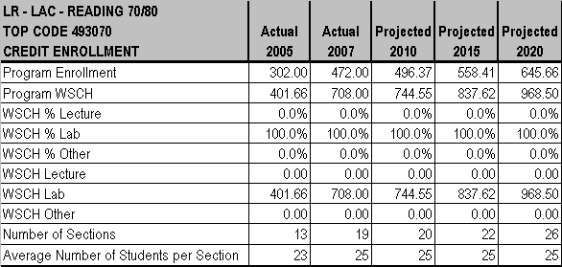
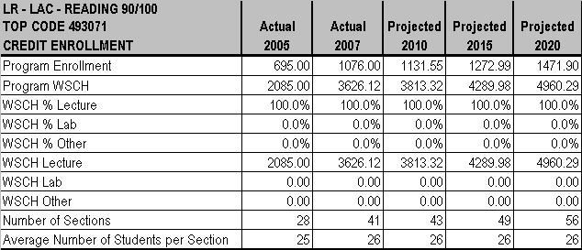

CHAPTER 3 - PROGRAMS AND SERVICES

• LERN 81: A shift in teaching methodology to 25% lecture and 75% collaborative. Lab will continue outside class and without credit.
• TUTR 10 A-D: No change in teaching methodology is forecast.
• LERN 48 & 49: Teaching methods will shift to 40% lecture and (thanks to a grant) 60% conceptual tool introduction.
• LERN 61 & 62: No change in teaching methodology is anticipated.
PERSONNEL
By 2010, the Learning Assistance Center will need the following additional personnel: 1 supervisor, 1 full-time classified staff, 30 student workers (for the new math facility in 2009), and part-time faculty FTEF can be decreased by 2, but 4 full-time faculty FTEF added. By the projected new building date of 2013, increasing personnel by 6 full-time classified staff, 7 part-time classified staff, and 10 student workers will be needed. Seven additional part-time classified staff members and 10 students workers will again be needed by 2020, but 2 part-time faculty FTEF positions can be eliminated.

MT. SAN ANTONIO COMMUNITY COLLEGE DISTRICT EDUCATIONAL MASTER PLAN - Page 229
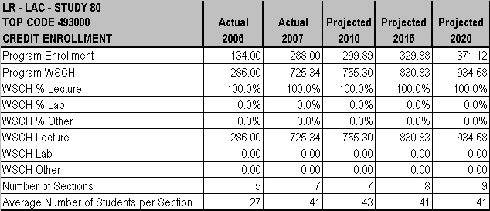
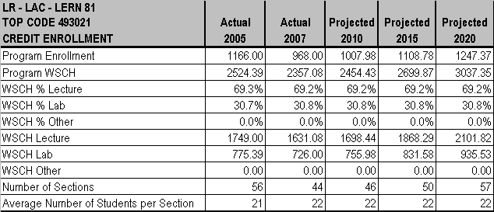

CHAPTER 3 - PROGRAMS AND SERVICES

MT. SAN ANTONIO COMMUNITY COLLEGE DISTRICT EDUCATIONAL MASTER PLAN - Page 230
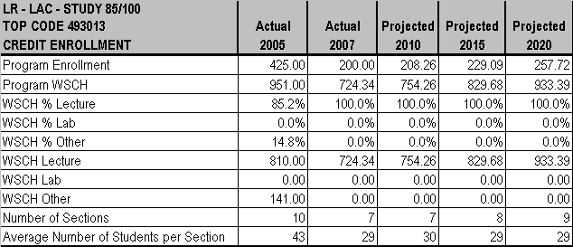
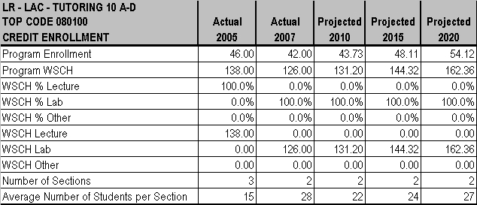

CHAPTER 3 - PROGRAMS AND SERVICES

MT. SAN ANTONIO COMMUNITY COLLEGE DISTRICT EDUCATIONAL MASTER PLAN - Page 231
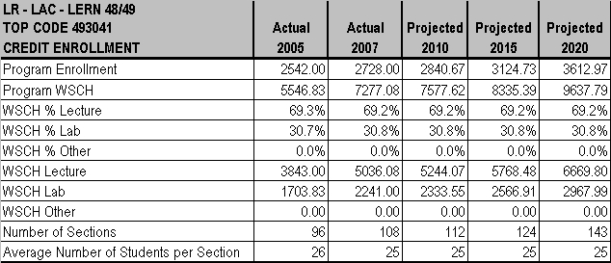
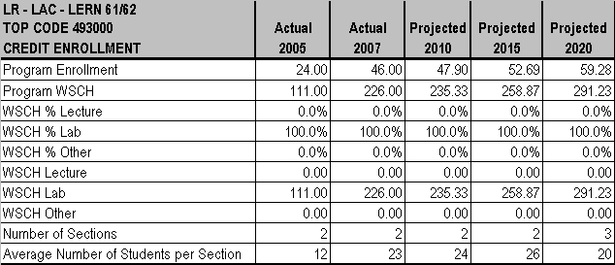
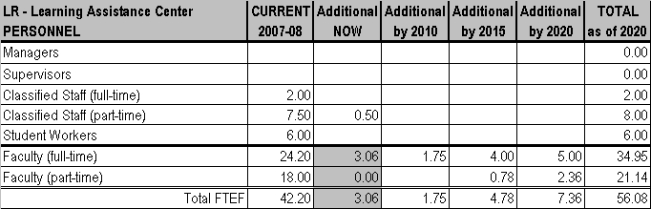

CHAPTER 3 - PROGRAMS AND SERVICES

MT. SAN ANTONIO COMMUNITY COLLEGE DISTRICT EDUCATIONAL MASTER PLAN - Page 232

CHAPTER 3 - PROGRAMS AND SERVICES

