CHAPTER 3 - PROGRAMS AND SERVICES

CHAPTER 3
PROGRAMS AND SERVICES
INSTRUCTION
Humanities and
Social Sciences
Division

MT. SAN ANTONIO COMMUNITY COLLEGE DISTRICT EDUCATIONAL MASTER PLAN - Page 179

CHAPTER 3 - PROGRAMS AND SERVICES

HUMANITIES AND SOCIAL SCIENCES DIVISION
Stephen Runnebohm, Dean
Jim Jenkins, Associate Dean

CURRENT PROGRAM
Humanities and Social Sciences is the largest academic division on campus, with 100 full-time and 250 part-time faculty and 8
departments, each with a department chair. The student newspaper, a nationally-recognized forensics program and The Teacher
Preparation Institute, the Honors Department and International Education are all part of the Division. The Division office is responsible for budgets, evaluations, hiring, supervising curriculum development and revision, space planning, furniture and equipment ordering for newly remodeled buildings, monitoring the completion of Student Learning Outcomes and Administrative Unit Objectives, and handling daily
issues on many fronts. The office fields about 150 student, 100 staff and 15 public contacts every week. At this time, the Division is
operating at maximum capacity.
FACILITIES
The Division office is located in Building 66-225; there is one conference room in 66-218, one meeting room in 66-231 and two conference rooms in Building 26. All classrooms in Buildings 26 and 66 are “smart” classrooms.
PERSONNEL
At this time the Division office employs 3 managers, 3 full-time classified staff and 2 student workers. An additional manager and a full-time classified staff position are needed now.

FUTURE PLANS
Increasing enrollment will require additional staff and resources, as the current staff and resources levels are overwhelmed at present.

FACILITIES
Additional administrative office space, classrooms and faculty office space are needed in addition to the similar space in Building 26. All systems need to be updated for emerging technologies.

PERSONNEL
By 2015, the Division will need an additional manager, 1 full-time classified staff position, 1 FTE part-time classified staff position and a student worker. By 2020, 1 FTE part-time classified staff and 1 student worker will be needed.

HSS DIVISION CURRENT Additional Additional Additional Additional TOTAL
PERSONNEL 2007-08 NOW by 2010 by 2015 by 2020 as of 2020
Managers 3.00 1.00 1.00 5.00
Supervisors 0.00
Classified Staff (full-time) 2.00 1.00 1.00 4.00
Classified Staff (part-time) 1.00 1.00 2.00
Student Workers 3.00 1.00 1.00 5.00
Total 8.00 2.00 0.00 4.00 2.00 16.00

MT. SAN ANTONIO COMMUNITY COLLEGE DISTRICT EDUCATIONAL MASTER PLAN - Page 180

CHAPTER 3 - PROGRAMS AND SERVICES

AMERICAN LANGUAGE
Stephen Runnebohm, Dean
Jim Jenkins, Associate Dean
Evelyn Hill-Enriquez, Chair

CURRENT PROGRAM
American Language college-level courses serve the academic English needs of non-native speaking students.

ENROLLMENT
American Language classes range in size from 25 to 30 students for ESL classes and consistently number 30 students for College Level classes. Waiting lists are small, if any.

FACILITIES
American Language currently has three classrooms in the Language Center and a lab in Humanities-East (Writing Center). One additional classroom is needed now.

TEACHING METHODOLOGIES
Interactive lecture with the computer lab is the primary teaching methodology

PERSONNEL
At this time, the American Language Department employs a .47 FTEF full-time, a .07 FTEF part-time faculty and a student worker. The
ESL program has 4.18 FTEF full-time faculty (one of which is on leave) and 5.81 FTEF part-time faculty. Neither program needs additional personnel at this time.

FUTURE PLANS
The Department plans to add classes in American Culture and Listening, and plans to develop ESL transfer-level reading and writing
courses.
ENROLLMENT
Enrollments are expected to grow at the same rate as overall District enrollment between now and 2020. Growth for this department is influenced by immigration laws and the worldwide political and financial economy. Growth is also affected by the fact that four-year universities have Basic Skills departments that are reducing or eliminating developmental courses for Basic Skills students.
FACILITIES
The Department will need one additional classroom by 2009; one more classroom and one work room by 2015; and one faculty office by
2020. Retaining currency with new “document” classrooms and replacing ceiling projectors will be ongoing needs between 2010 and
2020.
TEACHING METHODOLOGIES
Changes to teaching methodologies are anticipated for the ESL or college-level program. As student learning outcomes are developed, the modes of delivery and methodology will necessarily change to meet the needs of students.

PERSONNEL
By 2010, the College Level program will need an additional 0.53 FTEF full-time faculty and .267 FTEF part-time faculty. No additional
personnel will be needed through 2020. The ESL program will need 1 additional faculty member and 0.8 FTEF part-time faculty by 2010.
By 2015, an additional full-time faculty member is needed. By 2020, an additional full-time faculty member and 0.8 FTEF part-time faculty
will be needed.

MT. SAN ANTONIO COMMUNITY COLLEGE DISTRICT EDUCATIONAL MASTER PLAN - Page 181
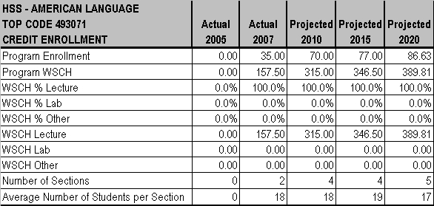
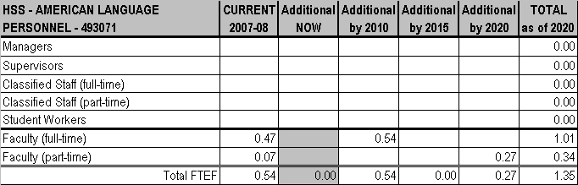

CHAPTER 3 - PROGRAMS AND SERVICES

MT. SAN ANTONIO COMMUNITY COLLEGE DISTRICT EDUCATIONAL MASTER PLAN - Page 182
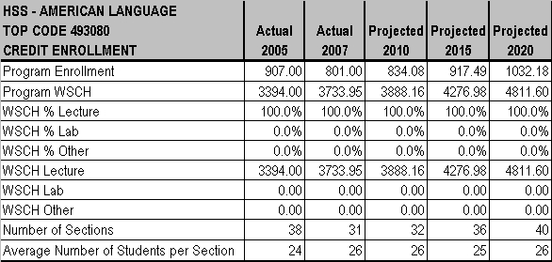
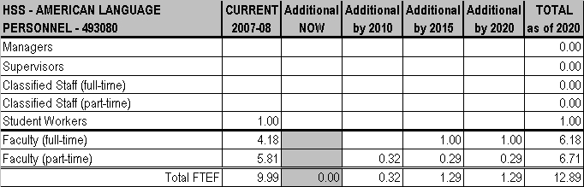

CHAPTER 3 - PROGRAMS AND SERVICES

MT. SAN ANTONIO COMMUNITY COLLEGE DISTRICT EDUCATIONAL MASTER PLAN - Page 183

CHAPTER 3 - PROGRAMS AND SERVICES

COMMUNICATION
Stephen Runnebohm, Dean
Jim Jenkins, Associate Dean
Liesel Reinhart, Chair

CURRENT PROGRAM
The Communication Department, which serves the transfer and general interest needs of students, has experienced a shift in enrollments across four semesters. The Department also serves other needs, though not occupational per se, such as self-improvement and business skill development. Major curriculum revisions in 2008-2009 will not reduce wait lists, but rather more likely increase them substantially
unless sections can be added.
ENROLLMENT
Class sizes range from 20 (for Honors classes) to 30 students with the average class size being 29 for lecture classes and 25 for lab classes. There are currently waiting lists for SPCH 1A in the morning, but not at other times.
FACILITIES
The Department currently has two classrooms in Humanities-North (26A), three classrooms in the 29 trailers, a forensics lab in 29C-3, and two storage closets for sets/costumes, video equipment, and event signage. A remodel to include a conference room and additional
faculty offices is underway in Humanities-South (26D) and is scheduled to be completed by Winter 2009. However, with the exception of the lab, total space for the Department is still insufficient to meet demand -- especially demand for weekday morning classrooms. Also needed now are a roving laptop lab for 2 to 3, website support, and four forensics lab desktop computers.
TEACHING METHODOLOGIES
Teaching methods include lecture (94%), lab (3%), and other (3%) such as SPCH 99 Special Projects, Speech.

PERSONNEL
At this time, there are 5 FTEF full-time and 8.43 FTEF part-time faculty, and 1 student worker. A .495 permanent part-time classified staff (lab supervisor) is needed now.

FUTURE PLANS
Future plans include a new degree emphasis area: professional/organizational communication and a one-unit skills developmental course connected to SPCH 1A, which is being written to give additional support in the development of public speaking, focusing on outlining,
research, and citation. These plans respond to the increased demand from employers for employee speech communication skills and from non-native students who require college-level instruction in public speaking, voice and diction. These plans also complement an increased interest in intercultural communication courses.
ENROLLMENT
Enrollments are expected to grow faster than overall District enrollment between now and 2015 and then grow at the same rate as the District until 2020.
FACILITIES
Despite remodeling underway, additional classrooms, a wardrobe/set room, and expansion of the video lab (including wall mount HD
digital camcorders with web uplinks) are needed by 2010 in Humanities-South (26D). By 2015, additional faculty office space and further expansion of the video lab are needed in Humanities-South (26D).

TEACHING METHODOLOGIES
It is anticipated that there will be a slight adjustment to the mix of teaching methodology: reducing lecture (87%), increasing lab (10%), and other (3%) such SPCH 99 Special Projects, Speech.

PERSONNEL
By 2010, the Department will need to reduce part-time faculty by 1 FTEF, but add 2 full-time faculty members. This same staffing change
will need to be repeated by 2015. By 2020, part-time staff will again need to be reduced by 1 person and 1 full--time faculty position needs
to be filled.

MT. SAN ANTONIO COMMUNITY COLLEGE DISTRICT EDUCATIONAL MASTER PLAN - Page 184
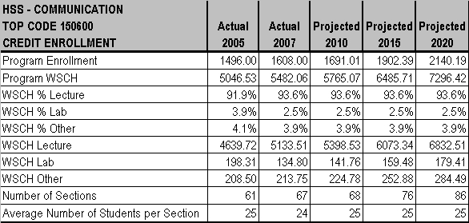
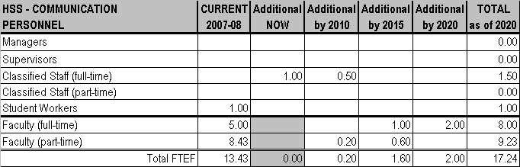

CHAPTER 3 - PROGRAMS AND SERVICES

MT. SAN ANTONIO COMMUNITY COLLEGE DISTRICT EDUCATIONAL MASTER PLAN - Page 185

CHAPTER 3 - PROGRAMS AND SERVICES

EDUCATION
Stephen Runnebohm, Dean
Jim Jenkins, Associate Dean
Rosa Preciado, Chair

CURRENT PROGRAM
The Education Department serves the transfer needs of students.

ENROLLMENT
Education class size (and average size) is generally 35 students. Currently, there is a waiting list of two students for EDUC 10.
FACILITIES
Education has one classroom in the Humanities-North (26A) building. Space and existing technology are sufficient at this time. Needed classrooms are shared with the Psychology Department.
TEACHING METHODOLOGIES
Education uses only lecture as a teaching methodology.

PERSONNEL
Education has a 0.6 FTEF full-time faculty member.

FUTURE PLANS
The continuing need for K-12 teachers is the primary factor affecting growth of this program.

ENROLLMENT
Education enrollments are expected to grow at the same rate as the District now through 2020.
FACILITIES
If the need arises for greater lab use, the potential exists to use Psychology Department facilities.
TEACHING METHODOLOGIES
Education has no plans to change teaching methods at this time, but greater use of technology will continue to enhance the classroom experience.
PERSONNEL
By 2010, the Education department will need an additional 0.6 FTEF part-time faculty.

MT. SAN ANTONIO COMMUNITY COLLEGE DISTRICT EDUCATIONAL MASTER PLAN - Page 186
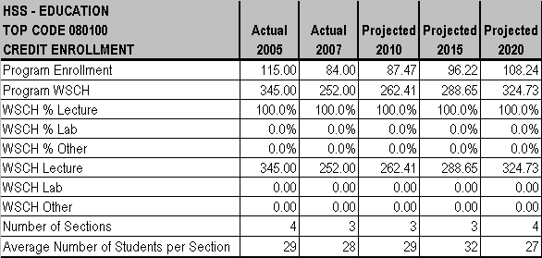
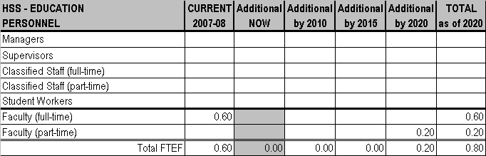

CHAPTER 3 - PROGRAMS AND SERVICES

MT. SAN ANTONIO COMMUNITY COLLEGE DISTRICT EDUCATIONAL MASTER PLAN - Page 187

CHAPTER 3 - PROGRAMS AND SERVICES

ENGLISH
Stephen Runnebohm, Dean
Jim Jenkins, Associate Dean
Gary Enke, Chair

CURRENT PROGRAM
English, which also encompasses Writing, Creative Writing, Literature, Comparative Literature and Classics, primarily serves the transfer needs of students; writing also serves the general interest needs of students.
ENROLLMENT
Class sizes for English range from 20 (for Honors classes) to 30; the average class size is 29. Creative Writing class sizes consistently
number 30 students. Writing class sizes range from 25 to 30; the average class size is 29. Literature, Comparative Literature and Classics class sizes consistently number 30 students. There are currently 2 persons on the waiting list for LIT 36 Introduction to Mythology.

FACILITIES
English and Literature programs currently share many rooms: one classroom in Bldg. 14, three classrooms in Bldg. 15, three classrooms in Bldg. 16, and 15 classrooms in Humanities-North (26A). English will move from Buildings 14, 15, and 16, and will occupy five new classrooms in the newly-remodeled Humanities-South (26D). This move results in an absence of any space for growth for a program that historically grows at a significantly higher rate than the College as a whole.

TEACHING METHODOLOGIES
English uses lecture (96%) and distance learning (4%); Creative Writing uses lecture (50%) and distance learning (50%); Writing, Literature, Comparative Literature and Classics use lecture (100%).
PERSONNEL
English has 32.89 FTEF full-time and 69.20 FTEF part-time faculty currently. In addition, the following support staff is shared: a .495 permanent part-time classified staff member and 5 student workers. One full-time classified staff employee and 1 student worker are needed now. An additional full-time faculty member and 2 FTEF additional part-time faculty are needed.

FUTURE PLANS
Composition classes are a central part of the Learning Communities program. Expansion of that program will necessitate offering more
sections of these courses. Other plans include a literary magazine with national presence; Summer Writers’ Workshop; Associate Arts in
Liberal Studies with Creative Writing Emphasis; Honors Creative Writing; and Memoir and Creative Non-Fiction class. Mexican-American
Literature will be offered Spring 2009 and African-American Literature may be offered at the same time, with both a part of the Learning
Communities program.
ENROLLMENT
Between now and 2020, enrollments are expected to grow at the same rate as the District overall. Cal Poly Pomona will be offering fewer
sections of pre-collegiate and college-level composition courses due to state budget cuts, and this will likely lead to increased demand.
FACILITIES
English will need two additional classrooms and four roving labs (with laptops, printer, and cart) by 2010. Two additional classrooms and four roving labs will again be needed by 2015 and again by 2020.

TEACHING METHODOLOGIES
No change to teaching methodology is anticipated.
PERSONNEL
By 2010, 2 additional full-time faculty members and 6 part-time faculty members will be needed, as well as 1 additional student worker. By
2015, English will need 4 additional full-time faculty members. Also by 2015, 1 part-time classified staff and 1 additional student worker will
be needed. By 2020, English will again need 4 additional full-time plus 1 part-time faculty. The addition of 2 student workers is also
needed by 2020.

MT. SAN ANTONIO COMMUNITY COLLEGE DISTRICT EDUCATIONAL MASTER PLAN - Page 188
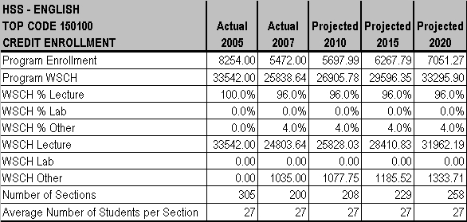
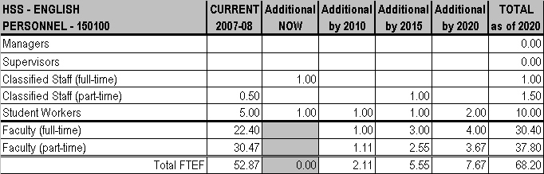

CHAPTER 3 - PROGRAMS AND SERVICES

MT. SAN ANTONIO COMMUNITY COLLEGE DISTRICT EDUCATIONAL MASTER PLAN - Page 189
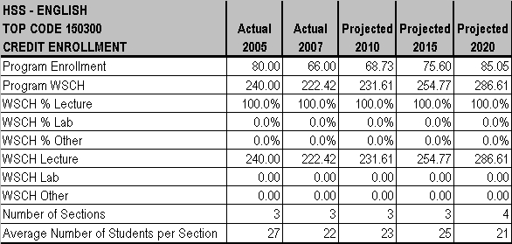
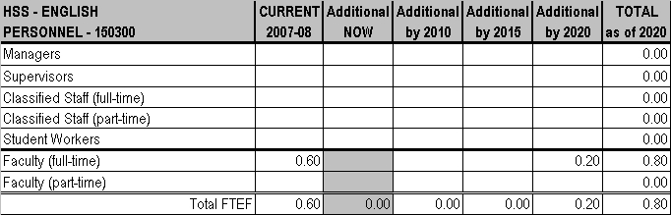

CHAPTER 3 - PROGRAMS AND SERVICES

MT. SAN ANTONIO COMMUNITY COLLEGE DISTRICT EDUCATIONAL MASTER PLAN - Page 190
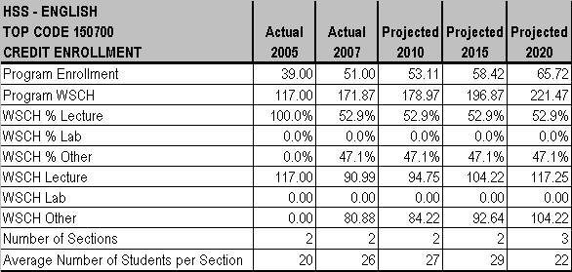
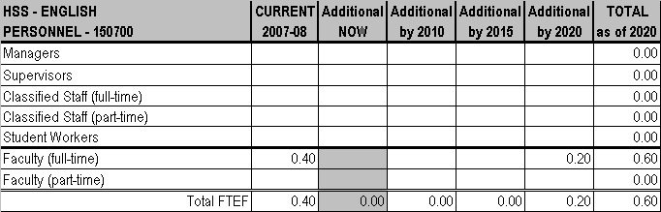

CHAPTER 3 - PROGRAMS AND SERVICES

MT. SAN ANTONIO COMMUNITY COLLEGE DISTRICT EDUCATIONAL MASTER PLAN - Page 191
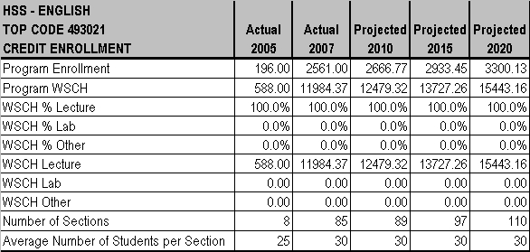
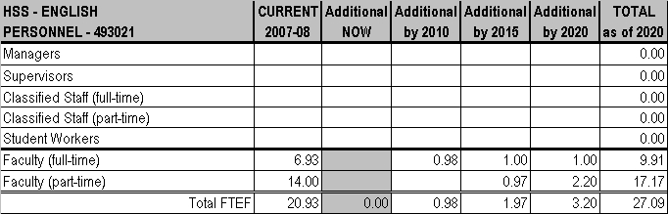

CHAPTER 3 - PROGRAMS AND SERVICES

MT. SAN ANTONIO COMMUNITY COLLEGE DISTRICT EDUCATIONAL MASTER PLAN - Page 192

CHAPTER 3 - PROGRAMS AND SERVICES

ETHNIC STUDIES
Stephen Runnebohm, Dean
Jim Jenkins, Associate Dean
Tyler Trull, Chair

CURRENT PROGRAM
Ethnic Studies serves the transfer needs of students.

ENROLLMENT
Ethnic Studies class size (and average size) is consistently 35 students for lecture classes.
FACILITIES
Classroom and office space is seriously impacted at this time and this will be a continuing problem. Ethnic Studies shares the following
spaces with other departments: one classroom in Building 12, six classrooms in Building 14, one classroom in Building 15, and three
classrooms in the portion of the Humanities-North (26A). With the completion of construction in Humanities-South (26D), all classrooms for this program will be located in the newly-remodeled Building 26, but there is no space for growth beyond that.
TEACHING METHODOLOGIES
The teaching method used for Ethnic Studies is exclusively lecture (100%).
PERSONNEL
Ethnic Studies has a 0.80 full-time faculty member currently and needs no additional personnel at this time.

FUTURE PLANS
Plans are in process to add a second semester of Native American History the Spring of 2009.

ENROLLMENT
Enrollments are expected to grow at the same rate as District growth between now and 2020.

FACILITIES
Ethnic Studies will need one additional classroom by 2015. .
TEACHING METHODOLOGIES
No methodology changes are anticipated.

PERSONNEL
Ethnic Studies will need an additional 0.60 FTEF full-time faculty by 2015 and again in 2020.

MT. SAN ANTONIO COMMUNITY COLLEGE DISTRICT EDUCATIONAL MASTER PLAN - Page 193
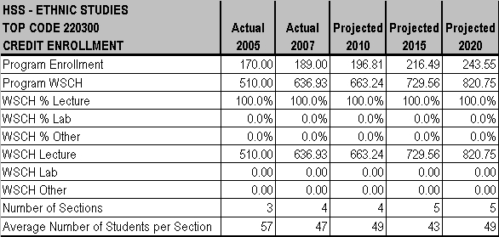
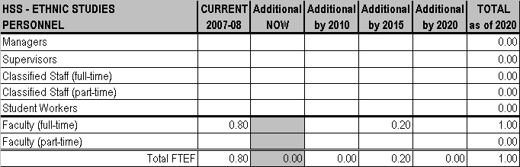

CHAPTER 3 - PROGRAMS AND SERVICES

MT. SAN ANTONIO COMMUNITY COLLEGE DISTRICT EDUCATIONAL MASTER PLAN - Page 194

CHAPTER 3 - PROGRAMS AND SERVICES

FOREIGN LANGUAGES
Stephen Runnebohm, Dean
Jim Jenkins, Associate Dean
Manuel Castillejos, Co-Chair
Americo Marano, Co-Chair

CURRENT PROGRAM
The Foreign Languages Department includes Chinese, French, German, Italian, Japanese and Spanish. The Department serves the transfer and general interest needs of students.

ENROLLMENT
Class size ranges from 24 to 35 students with the average class size being 33 students for lecture classes.
• Chinese class sizes range from 24 to 35; average class size is 31.
• French class sizes range from 24 to 35 students; average class size is 33.
• German class size consistently averages 35 students.
• Italian class sizes range from 24 to 35; average class size is 34.
• Japanese class sizes range from 24 to 35; average class size is 32.
• Spanish class sizes range from 24 to 35; average class size is 33.
FACILITIES
Foreign Languages growth has exceeded room capacity, so facilities are currently fragmented. Chinese, French, German, Japanese, and Spanish share two classrooms in Bldg. 15, four classrooms in Humanities-East (26B) and three classrooms in the Language Center (66). Italian is currently using a classroom in Humanities-East (26B), two classrooms in Humanities-North (26A) and a classroom in
Tech/Health-A (28A). Students cannot get to faculty offices easily and there is no lunchroom. The preferred location for expansion is
Humanities-East (26B). Current facility needs are one more classroom, office space for adjunct faculty, workroom for faculty, and
technology upgrades (including Internet) and/or equipment replacement to maintain currency. Other current needs are “ELMO” document cameras/projectors, blackboards, and whiteboards.
TEACHING METHODOLOGIES
• Chinese methods include lecture (80%), lab (1.5%), and multi-media tools (18.5%).
• French methods include lecture (91%) and lab (9%).
• German methods include lecture (75%) and lab (25%).
• Italian methods include lecture (60%), lab (0.5%), and various technology tools (39.5%).
• Japanese methods include lecture (86%) and lab (14%).
• Spanish methods include lecture (80%), lab (0.5%), and multi-media tools (19.5%).
PERSONNEL
• Chinese employs 1.10 FTEF full-time and 4.12 FTEF part-time faculty, and 1 student worker. An additional full-time faculty member is
needed now.
• French employs 1.01 FTEF full-time and 3.44 FTEF part-time faculty. No additional staff is needed currently.
• German employs 1.08 FTEF part-time faculty at this time. No additional staff is needed.
• Italian employs 0.67 FTEF full-time and 2.92 FTEF part-time faculty. No additional staff is needed now.
• Japanese employs 0.81 FTEF full-time and 6.21 FTEF part-time faculty currently; An additional full-time faculty is needed now.
• Spanish employs 6.06 FTEF full-time and 11.08 FTEF part-time faculty and 1 student worker. No additional staff is needed at this
time.

FUTURE PLANS
Foreign Languages proposes hiring a second full-time professor of Japanese to meet the growing demand, developing an Arabic program
by Spring 2009, and adding more classes, including Spanish Language Cinema and Spanish 13 (third level Spanish for Native Speakers).
ENROLLMENT
Between now and 2020, enrollments for German are not expected to grow. French is expected to grow at a slower rate than the District
overall. (In French, a new full-time coordinator has been hired and the program is expected to undergo changes). Italian is expected to

MT. SAN ANTONIO COMMUNITY COLLEGE DISTRICT EDUCATIONAL MASTER PLAN - Page 195
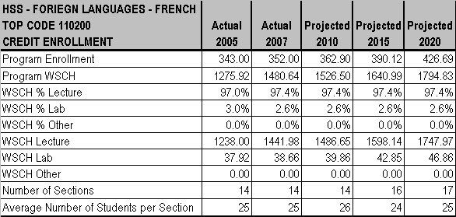

CHAPTER 3 - PROGRAMS AND SERVICES

grow at the same rate as the District. Chinese, Japanese, and Spanish anticipate that enrollments will grow at a faster rate than the overall District enrollment due to an increasing enrollment of Asian students, increasing interest in Chinese and Japanese language and culture, and an increasing enrollment of Latino students coupled with demand for Spanish in the workforce in the Southwestern U.S.
FACILITIES
By 2010, the Department will need more classrooms (in addition to the one needed in 2008) and it will be time for technology replacement as per the 3-year schedule. Within five years from today, new computers will also be needed.
TEACHING METHODOLOGIES
No changes in methodology are expected with the exception of French - changing to lecture (50%) and online (50%) - and German -
changing to lecture (80%) and audio-visual tools (20%).

PERSONNEL
• Chinese will need 1 additional full-time faculty member by 2010.
• French will need 1 additional half-time faculty member by 2010.
• German anticipates no need for additional staff between now and 2020.
• Italian will need 1 additional full-time faculty member by 2010; 0.6 FTEF part-time faculty by 2015; and 1 additional full-time faculty
member again by 2020.
• Japanese will need 1 additional full-time and 0.6 FTEF part-time faculty by 2010.
• Spanish will need by 2010, 2 additional full-time faculty members and 1 student worker. By 2020, 2 additional full-time faculty
members and 2 student workers will be needed.

MT. SAN ANTONIO COMMUNITY COLLEGE DISTRICT EDUCATIONAL MASTER PLAN - Page 196
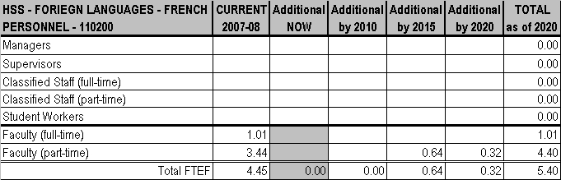
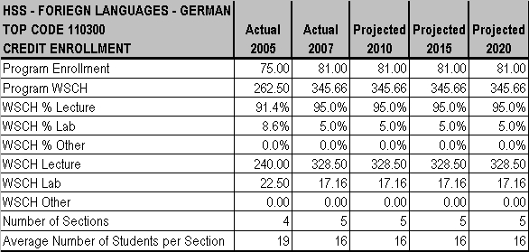
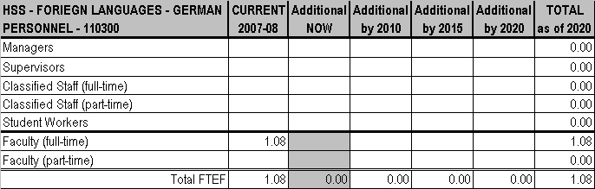

CHAPTER 3 - PROGRAMS AND SERVICES

MT. SAN ANTONIO COMMUNITY COLLEGE DISTRICT EDUCATIONAL MASTER PLAN - Page 197
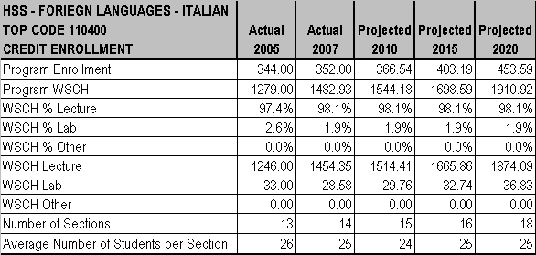
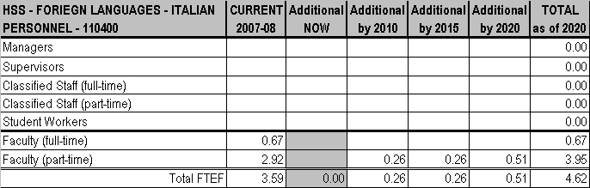

CHAPTER 3 - PROGRAMS AND SERVICES

MT. SAN ANTONIO COMMUNITY COLLEGE DISTRICT EDUCATIONAL MASTER PLAN - Page 198
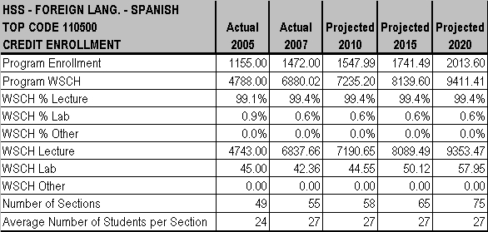
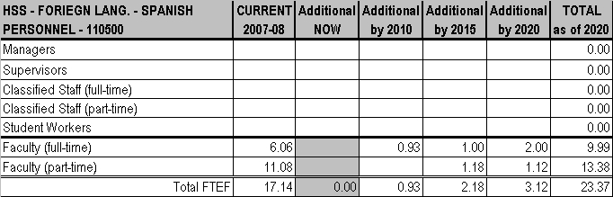

CHAPTER 3 - PROGRAMS AND SERVICES

MT. SAN ANTONIO COMMUNITY COLLEGE DISTRICT EDUCATIONAL MASTER PLAN - Page 199
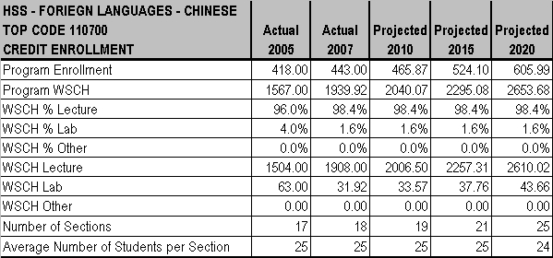
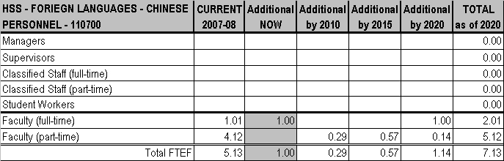

CHAPTER 3 - PROGRAMS AND SERVICES

MT. SAN ANTONIO COMMUNITY COLLEGE DISTRICT EDUCATIONAL MASTER PLAN - Page 200
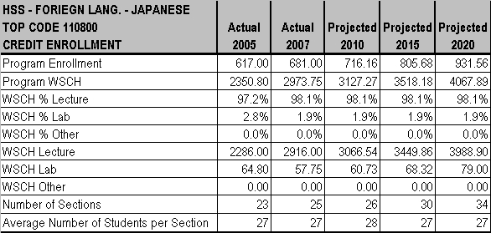
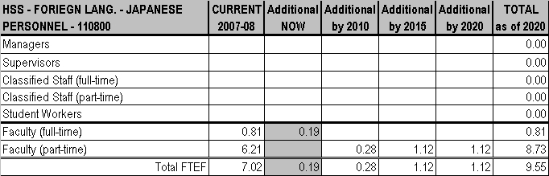

CHAPTER 3 - PROGRAMS AND SERVICES

MT. SAN ANTONIO COMMUNITY COLLEGE DISTRICT EDUCATIONAL MASTER PLAN - Page 201

CHAPTER 3 - PROGRAMS AND SERVICES

GEOGRAPHY
Stephen Runnebohm, Dean
Jim Jenkins, Associate Dean
Tyler Trull, Chair
Dafna Kohn, Instructor

CURRENT PROGRAM
Geography serves the transfer needs of students. .
ENROLLMENT
Geography class sizes range from 24 to 30 students. Lecture classes average 30 students; lab classes average 24 students. There are currently 2 students on the waiting list for GEOG 30 Geography of California, but there are typically not waiting lists for classes.
FACILITIES
Classroom and office space is impacted at this time and this will be a continuing problem. Geography shares the following space with
other departments: one classroom in Building 12, six classrooms in Building 14, one classroom in Building 15, and three classrooms in the portion of Humanities-North (26A) that has had construction completed. With the completion of construction in Humanities-South (26D), all classrooms for this program will be located in the newly-remodeled Building 26, but there is no more space for growth.

TEACHING METHODOLOGIES
Geography currently uses lecture (90%) and lab (10%) as the teaching methodologies.
PERSONNEL
Geography has 1.87 FTEF full-time and 2.28 FTEF part-time faculty now. No additional personnel is needed at this time.

FUTURE PLANS
Geography plans to offer a certificate in Geographic Information Systems by Spring 2009. Development of an area of emphasis in spatial thinking is also under consideration.
ENROLLMENT
Geography Department enrollments are expected to keep pace with projected District enrollment between now and 2020, primarily
because advances in geospatial technology have created tremendous growth within both academia and the work place. However, even though more growth is expected as these technologies evolve and become more accessible to the layperson, there is still a huge deficit in people well trained in the advanced aspects of these technologies.
FACILITIES
Geography will continue to share space even after classrooms now in Buildings 12, 14, and 15 are moved into Humanities-North (26A)
when construction is completed in December 2008. Geography will need a dedicated GIS lab with a computer for each student by 2015.
TEACHING METHODOLOGIES
Geography will use field trips designed to enhance student ability to process and analyze geographic information, so the new methodology mix will be lecture (80%), lab (10%), and field trips (10%).
PERSONNEL
Geography will need 1 additional full-time faculty member by 2010.

MT. SAN ANTONIO COMMUNITY COLLEGE DISTRICT EDUCATIONAL MASTER PLAN - Page 202
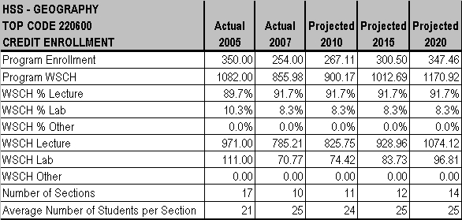
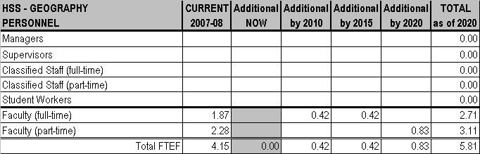

CHAPTER 3 - PROGRAMS AND SERVICES

MT. SAN ANTONIO COMMUNITY COLLEGE DISTRICT EDUCATIONAL MASTER PLAN - Page 203

CHAPTER 3 - PROGRAMS AND SERVICES

HISTORY
Stephen Runnebohm, Dean
Jim Jenkins, Associate Dean
Ralph Spaulding, Chair

CURRENT PROGRAM
History serves the transfer needs of students.

ENROLLMENT
History class size (and average size) is consistently 20 (for Honors classes) to 43 students for lecture classes. There is a significant waiting list for all classes.

FACILITIES
Classroom and office space is seriously impacted at this time and this will be a continuing problem. History shares the following space
with other departments: a classroom in Building 12, six classrooms in Building 14, one classroom in Building 15, and three classrooms in
the portion of the Humanities-North (26A) building that has had construction completed. With the completion of construction in Humanities-
South (26D), all classrooms for this program will be located in the newly-remodeled Building 26, but with no more space for growth.

TEACHING METHODOLOGIES
History uses lecture (100%) but offers a few online and hybrid classes.

PERSONNEL
The History has 9.20 FTEF full-time and 9.60 FTEF part-time faculty and 1 student worker. Two additional full-time faculty members, a
half-time classified staff employee, one student worker, and one administrator (either an assistant or associate dean) are needed now.

FUTURE PLANS
Plans are in process to add a second semester of Native American History in the Spring of 2009; future plans also include women’s studies, non-transfer courses, and classes such as Mid-East History.

ENROLLMENT
Enrollments are expected to grow at a faster rate (approximately 3%) than the District rate now through 2020.
FACILITIES
History needs 2 classrooms and 10 office spaces close to Humanities-North (26) by 2020. Updated technology is an ongoing need (every
3 years) now through 2020.
TEACHING METHODOLOGIES
Although classes will remain lecture in style, the Department anticipates increasing the number of online and hybrid offerings to at least 20
sections.
PERSONNEL
History needs the following personnel additions by 2010: 2 full-time faculty members (including 1 for Art History), 1 part-time faculty
member, 1 full-time classified person, and 2 student workers. By 2015, 2 additional full-time faculty members and 1 part-time faculty
members are needed. By 2020, the department will need 3 full-time (including 1 for Art History) and 1 part-time faculty members.

MT. SAN ANTONIO COMMUNITY COLLEGE DISTRICT EDUCATIONAL MASTER PLAN - Page 204
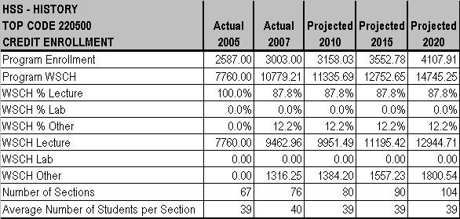
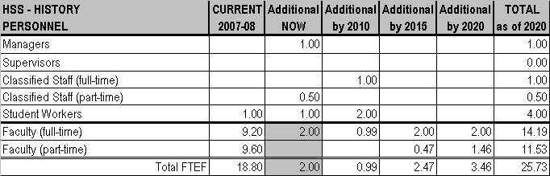

CHAPTER 3 - PROGRAMS AND SERVICES

MT. SAN ANTONIO COMMUNITY COLLEGE DISTRICT EDUCATIONAL MASTER PLAN - Page 205

CHAPTER 3 - PROGRAMS AND SERVICES

JOURNALISM
Stephen Runnebohm, Dean
Jim Jenkins, Associate Dean
Gary Enke, Chair

CURRENT PROGRAM
Journalism, which includes Media & Communications, serves the transfer needs of students.

ENROLLMENT
Journalism class sizes range from 20 (for Honors classes) to 30; the average class size is 25. Media & Communications class sizes consistently number 30 students. There is currently one person on the waiting list for JOUR 100 Mass Media & Society.

FACILITIES
Journalism uses one classroom in Bldg. 14 and one classroom/lab in Building 29D.
TEACHING METHODOLOGIES
Journalism uses lecture (56%) and lab (44%), while Media & Communications is entirely lecture (100%).

PERSONNEL
There are 1.60 FTEF full-time and 0.87 FTEF part-time faculty and 3 student workers in Journalism; there are 0.20 FTEF full-time and 0.40 FTEF part-time faculty in Media & Communications. No additional personnel are needed at this time.

FUTURE PLANS
Journalism would like to publish a student magazine in fall and spring; increase the student newspaper to weekly; expand Public Relations and Online Journalism; and offer Spanish-Language Journalism.
ENROLLMENT
Between now and 2020, enrollments for Journalism are expected to grow at a faster rate than the District overall; Media & Communications enrollments are expected to grow at the same rate.
FACILITIES
Journalism will need one classroom/lab with computers by 2015.

TEACHING METHODOLOGIES
It is anticipated that teaching methodology will change to lecture (66%) and distance learning (33%), as adding a distance learning section
is planned.

PERSONNEL
By 2010, 1 additional full-time faculty member specific to this program will be needed. By 2015, 1 additional full-time faculty is needed. One additional full-time faculty member will again be needed by 2020.

MT. SAN ANTONIO COMMUNITY COLLEGE DISTRICT EDUCATIONAL MASTER PLAN - Page 206
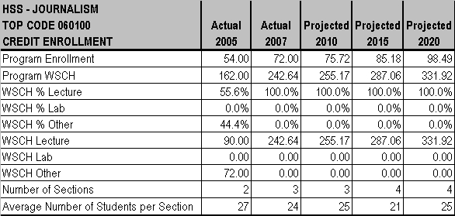
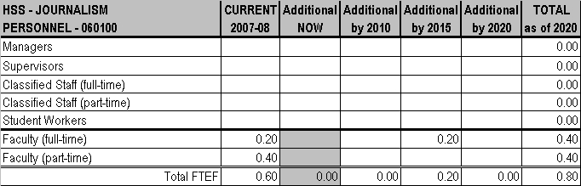

CHAPTER 3 - PROGRAMS AND SERVICES

MT. SAN ANTONIO COMMUNITY COLLEGE DISTRICT EDUCATIONAL MASTER PLAN - Page 207
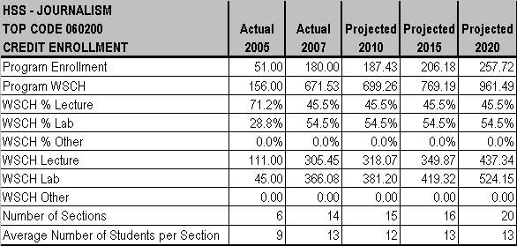
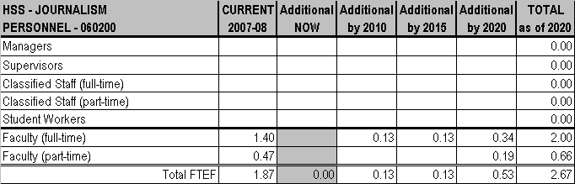

CHAPTER 3 - PROGRAMS AND SERVICES

MT. SAN ANTONIO COMMUNITY COLLEGE DISTRICT EDUCATIONAL MASTER PLAN - Page 208

CHAPTER 3 - PROGRAMS AND SERVICES

PHILOSOPHY
Stephen Runnebohm, Dean
Jim Jenkins, Associate Dean
David Medina, Chair

CURRENT PROGRAM
The Philosophy Department serves the transfer needs of students.

ENROLLMENT
Philosophy class sizes range from 20 (for Honors classes) to 35 students. Average class size is 34 students for lecture classes.
FACILITIES
There are two classrooms (shared with Sociology) in Building 16 which need renovation, plus three classrooms and one combination
lab/classroom in Humanities-North (26A). With the completion of construction in Humanities-South (26D), all classrooms for this program will be located in the newly-remodeled Building 26; however, there is no space for growth.

TEACHING METHODOLOGIES
Philosophy’s teaching methodology is lecture: classroom (76%) and distance/online (23%).

PERSONNEL
Philosophy currently has 4.40 FTEF full-time and 11.20 FTEF part-time faculty. The following additional personnel are needed now: 1 fulltime faculty member, 0.6 FTEF part-time faculty, a 0.495 permanent part-time classified staff person, and 2 student workers.

FUTURE PLANS
New programs planned for Philosophy include Environmental Philosophy (to be written by 2010), Aesthetics, and Cognitive Science.

ENROLLMENT
Enrollments for Philosophy are expected to grow at a faster rate than District enrollment. Contributing factors will be the growth of online courses and new course development.
FACILITIES
The Philosophy Department will need an additional classroom and 3 office spaces by 2020. On an on-going basis through 2020, the Department needs new technology upgrades to remain current.
TEACHING METHODOLOGIES
Lecture will continue as the primary teaching methodology, but the Department anticipates growth in online and hybrid class offerings.

PERSONNEL
Philosophy will need a full-time and 0.6 FTEF part-time faculty and a full-time classified staff person by 2010. By 2015, and again in 2020, the Department will need 1 additional full-time faculty member, as well as 2 additional part-time faculty members.

MT. SAN ANTONIO COMMUNITY COLLEGE DISTRICT EDUCATIONAL MASTER PLAN - Page 209
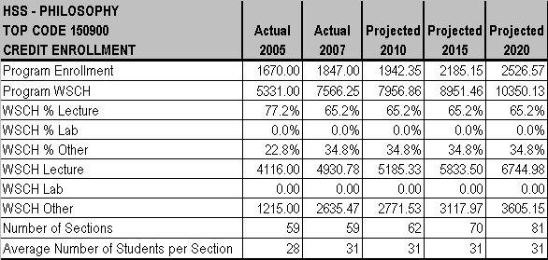
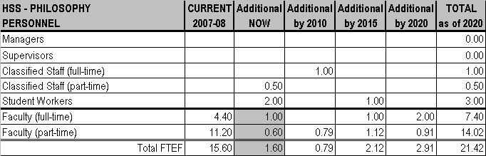

CHAPTER 3 - PROGRAMS AND SERVICES

MT. SAN ANTONIO COMMUNITY COLLEGE DISTRICT EDUCATIONAL MASTER PLAN - Page 210

CHAPTER 3 - PROGRAMS AND SERVICES

POLITICAL SCIENCE
Stephen Runnebohm, Dean
Jim Jenkins, Associate Dean
Tyler Trull, Chair

CURRENT PROGRAM
Political Science serves the transfer needs of students.

ENROLLMENT
Political Science class sizes range from 20 (for Honors classes) to 43 students with the average lecture class size being 40 students.
Enrollment figures for 2007 appear to have declined, but a faculty sabbatical leave and then a 20% reassigned time arrangement were the root of the temporary change in figures.
FACILITIES
Classroom and office space are seriously impacted at this time and this will be a continuing problem. Full-time instructors share offices and there is no office space for part-time faculty. Political Science shares the following spaces with History, Ethnic Studies and Geography: a classroom in Building 12, six classrooms in Building 14, one classroom in Building 15, and three classrooms in the portion of HumanitiesNorth (26A) that has had construction completed. With the completion of construction in Humanities-South (26D), all classrooms for the program will be located in the newly-remodeled Building 26; however, no more space for growth exists.
TEACHING METHODOLOGIES
The teaching method used for Political Science is exclusively lecture (100%).

PERSONNEL
Political Science is experiencing a serious and immediate need for additional personnel, particularly administrative and classified staff
support. Political Science has 4 full-time and 5 part-time faculty members at this time. The lack of administrative and classified support is a priority item to address. Adding a 0.495 permanent part-time classified staff person is important at this time.

FUTURE PLANS
Future classes planned in the Political Science department include State and Local Government, Women in Politics, Middle Eastern Politics, Ethnic/Minority Politics, and Environmental Politics. Development will begin about 2009.

ENROLLMENT
The Political Science Department expects enrollment to grow faster than overall District enrollment between now and 2020, primarily because state budget cuts are deflecting more students from universities to community colleges and there are continued population increases in the District.
FACILITIES
Political Science will continue to share space even after classrooms now in Buildings 12, 14, and 15 are moved into Humanities-North (26A) when construction is completed in December 2008. Despite the upcoming move, the Political Science Department will still have a serious lack of space. Two classrooms near Humanities-North (26A) and at least four office spaces will be needed by 2020. Technology replacement to maintain currency is also needed every three years through 2020.
TEACHING METHODOLOGIES
Political Science anticipates increasing the number of sections (to at least three) of online and hybrid offerings.

PERSONNEL
From now through 2020, addressing the serious shortage of administrative support, classified support, and faculty staffing is a primary
concern for the Department. By 2010, Political Science will need to add 1 FTEF full-time and 1 FTEF part-time faculty members, plus 1 fulltime classified staff person. By 2015, 1 full-time and 1 part-time additions to faculty will be needed; and the same staffing increase is
needed again by 2020.

MT. SAN ANTONIO COMMUNITY COLLEGE DISTRICT EDUCATIONAL MASTER PLAN - Page 211
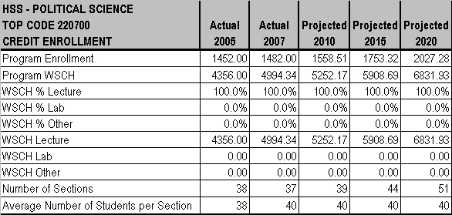
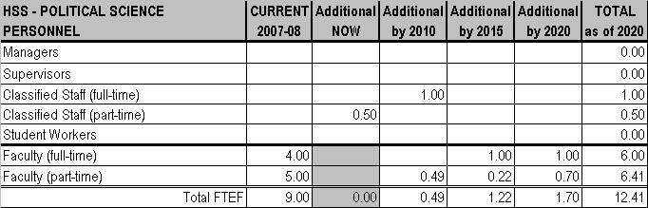

CHAPTER 3 - PROGRAMS AND SERVICES

MT. SAN ANTONIO COMMUNITY COLLEGE DISTRICT EDUCATIONAL MASTER PLAN - Page 212

CHAPTER 3 - PROGRAMS AND SERVICES

PSYCHOLOGY
Stephen Runnebohm, Dean
Jim Jenkins, Associate Dean
Rosa Preciado, Chair

CURRENT PROGRAM
The Psychology Department serves primarily the transfer needs of students and some occupational needs for disciplines such as Nursing. Some certificate programs also include Psychology courses (e.g. Alcohol & Drug, Psychiatric Technician).
ENROLLMENT
Psychology class sizes range from 20 (for Honors classes) to 50 students. The average class size is 41 for lecture classes.

FACILITIES
Psychology currently has six classrooms, only two of which accommodate 50 students, and one lab classroom in Humanities-North (26A).
The restricted lab in this building is not fully enforced which has led to loss/damage of equipment and the distance between 26A/B
decreases interaction with students and access to facilities. Larger classrooms that can accommodate up to 50 students and/or more
classrooms (for smaller sized classes) are needed now in Building 26, as are basic projectors, ELMOs, and operational access.

TEACHING METHODOLOGIES
Psychology uses the following teaching methods: lecture (87%), lab (4%), and distance learning (9%).

PERSONNEL
At this time, Psychology has 5.6 FTEF full-time and 7.2 FTEF part-time faculty.

FUTURE PLANS
Psychology plans to develop new coursework in Child Development, Psychology of Prejudice, and Psychology of Asian American Experience and reactivate coursework for Counseling Practices, Human Relations, and Gerontology/Death & Dying.

ENROLLMENT
Enrollments for Psychology are expected to grow at the same rate as overall District enrollment now through 2020. Contributing factors are a continued popularity of the discipline, the increasing influence of neuroscience and psychopharmacology, the increased focus of research on diversity affecting human behavior (e.g., gender, age, culture/ethnicity), and increasing intra-campus interest from related disciplines (such as Nursing).
FACILITIES
By 2015, the Psychology Department will need to replace lab computers; eventually 54 computers will be needed.

TEACHING METHODOLOGIES
Psychology has no plans to change teaching methods at this time, but greater use of technology will continue to enhance the classroom experience.

PERSONNEL
Psychology will need an additional 0.4 FTEF part-time faculty member by 2015.

MT. SAN ANTONIO COMMUNITY COLLEGE DISTRICT EDUCATIONAL MASTER PLAN - Page 213
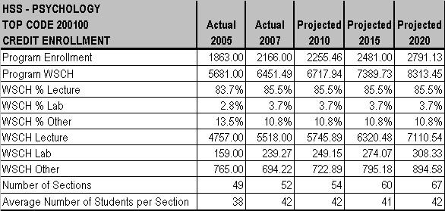
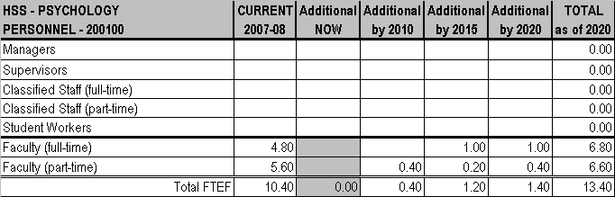

CHAPTER 3 - PROGRAMS AND SERVICES

MT. SAN ANTONIO COMMUNITY COLLEGE DISTRICT EDUCATIONAL MASTER PLAN - Page 214
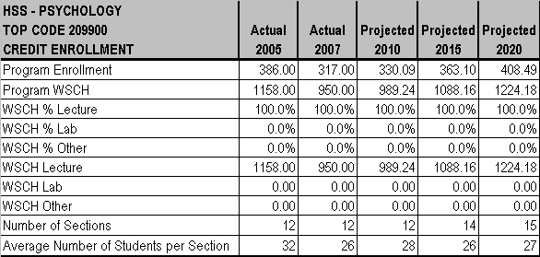
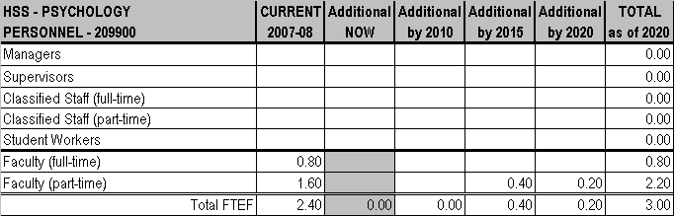

CHAPTER 3 - PROGRAMS AND SERVICES

MT. SAN ANTONIO COMMUNITY COLLEGE DISTRICT EDUCATIONAL MASTER PLAN - Page 215

CHAPTER 3 - PROGRAMS AND SERVICES

SIGN LANGUAGE / INTERPRETING
Stephen Runnebohm, Dean
Jim Jenkins, Associate Dean
Bob Stuard, Chair

CURRENT PROGRAM
The Sign Language program serves the general education, elective and transfer needs of students. In addition, many students take Sign Language for personal reasons or out of general interest. The Interpreting program meets the occupational needs of students training to be Sign Language interpreters. The Department recently made major revisions to the Interpreting program, including two new required
courses, three new electives and four amended courses.
ENROLLMENT
Class sizes range from 25 to 35 for Sign Language courses and from 14 to 25 students for Interpreting courses. The maximum class size for upper level Interpreting classes is now set at 14. Average class size for both programs is 26 students. Between 2005-06 and 2006-07, there was a 26% increase in overall program enrollment, and this growth is expected to continue.
FACILITIES
The Department currently has two classrooms, 66-201 and 66-205, and two offices, one for the chair and one for full-time faculty. The
current facilities have no space available for growth. New faculty offices and classrooms should be included on the space request list if the bond measure is approved.

TEACHING METHODOLOGIES
Teaching methods include lecture (89%) and lab (11%) for Interpreting and lecture only (100%) for Sign Language.
PERSONNEL
At this time, Sign Language has 2.43 FTEF full-time and 2.16 FTEF part-time faculty; Interpreting has 0.60 FTEF full-time faculty, 2.23
FTEF part-time, and a .30 hourly student worker. With combined growth in students majoring in Interpreting and the addition of new
courses to that program, there is an immediate need for a new full-time faculty member focusing on Interpreting. At this time all the upperlevel courses are taught by part-time faculty.

FUTURE PLANS
The U.S. Dept. of Labor Bureau of Labor Statistics categorizes the growth rate for the field of Interpreting (for all languages, including Sign Language) as “much faster than the average.” Between 2006 and 2016, a 24% growth in the field of Interpreting in general is projected. With the advent of Video Relay Interpreting (VRI), the demand for Sign Language interpreters has increased dramatically. There are no firm statistics on expected growth, but given the increased competition among VRI providers to hire interpreters, it is probably that growth in the field will far exceed the projections.
ENROLLMENT
Enrollment is expected to far exceed the rate of overall District enrollment between now and 2020.
FACILITIES
If the bond measure is approved, the Department needs new faculty offices and classrooms.

TEACHING METHODOLOGIES
Approximately 20% of the teaching methods may possibly shift to hybrid classes. The use of technology to evaluate student signing via Internet/Web access is also expected to grow in both programs.

PERSONNEL
By 2010, Interpreting will need an additional full-time faculty member and a 0.495 permanent part-time classified staff employee. By 2015, Sign Language will need an additional full-time faculty member and 0.6 FTEF part-time faculty.

MT. SAN ANTONIO COMMUNITY COLLEGE DISTRICT EDUCATIONAL MASTER PLAN - Page 216
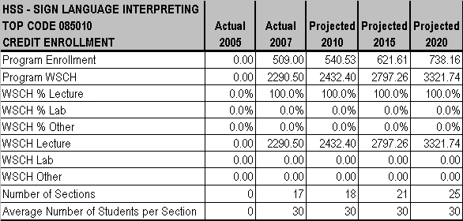
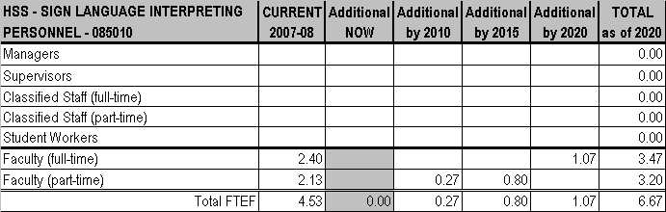

CHAPTER 3 - PROGRAMS AND SERVICES

MT. SAN ANTONIO COMMUNITY COLLEGE DISTRICT EDUCATIONAL MASTER PLAN - Page 217

CHAPTER 3 - PROGRAMS AND SERVICES

SOCIAL SCIENCES
Stephen Runnebohm, Dean
Jim Jenkins, Associate Dean
David Medina, Chair

CURRENT PROGRAM
Social Sciences serves the transfer needs of students.

ENROLLMENT
Class sizes for the Social Sciences range from 20 (for Honors classes) to 35. Average lecture class size is 34. There is currently a waiting list of 17 students for the SOC 5 class.

FACILITIES
With the completion of construction to Humanities-South (26D), all classrooms for this program will be located in the newly-remodeled Building 26, but there is no additional space for growth.

TEACHING METHODOLOGIES
The teaching methodology for Social Sciences is lecture (both classroom and distance learning). Distance learning is growing in usage.

PERSONNEL
Social Sciences has 2.0 FTEF full-time and 2.60 FTEF part-time faculty. One additional full-time faculty member is needed now.

FUTURE PLANS
Future plans for Social Sciences include a Certificate in Elder Care/Gerontology Aide, a Certificate in Social Welfare, and Gender Study: An Introduction to GLBT (Gay, Lesbian, Bi-Sexual, Trans-sexual) Studies.
ENROLLMENT
Social Sciences expects enrollments to grow at a faster rate than the overall District rate of growth. Contributing factors are an aging population and more prisons being built.
FACILITIES
By 2015, Social Sciences will need one classroom and two offices. By 2020, one additional classroom is needed. There is also a potential need for gerontology lab equipment sometime in the future.
TEACHING METHODOLOGIES
Lecture will continue as the only teaching methodology for Social Sciences but more online courses will likely be offered. Certificates may require placement of students in experiential learning settings.
PERSONNEL
Social Sciences will need an additional 1.2 FTEF part-time faculty members by 2010; and the same increase again by 2020. By 2015, 1 additional full-time faculty member is needed.

MT. SAN ANTONIO COMMUNITY COLLEGE DISTRICT EDUCATIONAL MASTER PLAN - Page 218
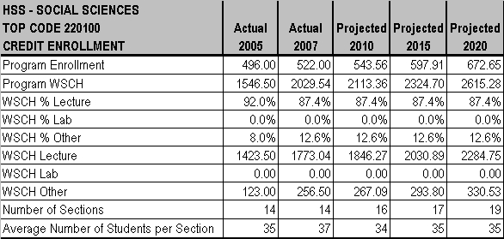
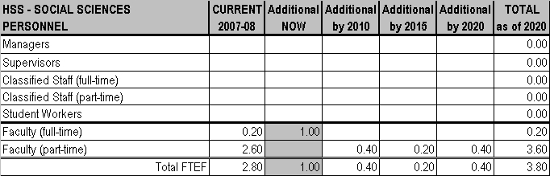

CHAPTER 3 - PROGRAMS AND SERVICES

MT. SAN ANTONIO COMMUNITY COLLEGE DISTRICT EDUCATIONAL MASTER PLAN - Page 219

CHAPTER 3 - PROGRAMS AND SERVICES

SOCIOLOGY
Stephen Runnebohm, Dean
Jim Jenkins, Associate Dean
David Medina, Chair

CURRENT PROGRAM
Sociology serves the transfer needs of students.

ENROLLMENT
Sociology Department class sizes range from 20 (for Honors classes) to 50. The average lecture class size is 44.
FACILITIES
Sociology shares two classrooms in Building 16 (which need renovation), plus three classrooms and one combination lab/classroom in
Humanities-North (26A). Two additional classrooms in the Humanities 26 Complex are needed now by the Sociology Department. With the completion of construction in Humanities-South (26D), all classrooms for this program will be located in the newly-remodeled Building 26, but there is no space for expansion.
TEACHING METHODOLOGIES
The teaching methodology used for Sociology is lecture (both classroom and distance learning). Distance learning is growing in usage.
PERSONNEL
Sociology currently has 4.40 FTEF full-time and 11.79 part-time faculty members. An additional full-time faculty member is needed now.

FUTURE PLANS
The Sociology Department has several new courses in the planning process: Sociology of Religion (which is the closest to completion), Global Citizen, Asian-American Community, Sociology of Women, African-American in Contemporary Society, Social Research Methods, and Statistics for Sociology.
ENROLLMENT
Sociology expects enrollments to grow at a faster rate than the overall District rate. Contributing factors are the popularity of the discipline in universities and an emphasis on global issues, including immigration and global economy.
FACILITIES
By 2010, Sociology will need one additional classrooms in the Humanities 26 Complex and a Sociology Statistics & Research Lab with
computers and applicable software. By 2015, two additional offices in the Humanities 26 Complex and two additional classrooms also will be needed. By 2020, Sociology will need two offices and an additional two classrooms.

TEACHING METHODOLOGIES
The Sociology Department anticipates a change in teaching methodology to lecture (80%) and a Research Methods lab (20%).
PERSONNEL
The Sociology Department will need 1 additional FTEF full-time and 2.4 FTEF additional part-time faculty members by 2010. In 2015, Sociology will need one additional FTEF full-time member. By 2020, a full-time and 2.4 FTEF part-time faculty will be needed.

MT. SAN ANTONIO COMMUNITY COLLEGE DISTRICT EDUCATIONAL MASTER PLAN - Page 220
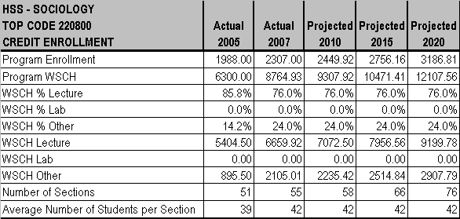
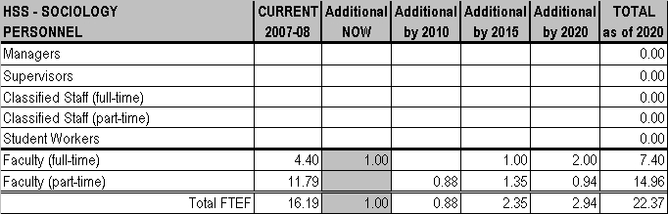

CHAPTER 3 - PROGRAMS AND SERVICES

MT. SAN ANTONIO COMMUNITY COLLEGE DISTRICT EDUCATIONAL MASTER PLAN - Page 221

CHAPTER 3 - PROGRAMS AND SERVICES

MT. SAN ANTONIO COMMUNITY COLLEGE DISTRICT EDUCATIONAL MASTER PLAN - Page 222

CHAPTER 3 - PROGRAMS AND SERVICES

