CHAPTER 3 - PROGRAMS AND SERVICES

CHAPTER 3
PROGRAMS AND SERVICES
INSTRUCTION
Arts Division

MT. SAN ANTONIO COMMUNITY COLLEGE DISTRICT EDUCATIONAL MASTER PLAN - Page 117

CHAPTER 3 - PROGRAMS AND SERVICES

ARTS DIVISION
Sue Long, Dean

CURRENT PROGRAM
The Arts Division serves approximately 6,400 students, 7,000 staff members and 8,000 members of the general public each year. In
addition to the departmental offerings, the Division has an Art Gallery and has recently added a Public Art program with a supportive
Advisory Committee. The Division office helps students with academic process information and guidance, faculty with administrative and scheduling details, and departments with budgeting and records. The Division office also assists with planning and support of student group travel and on-campus events such as festivals, Art Gallery exhibitions and openings, Public Art events, and visiting artist series. Division staff work with Marketing to develop publicity and programs.
FACILITIES
The Division has an office (which will need to be relocated once the building it is in is demolished to open the Design Technology Center);
a conference room; an Art Gallery; Music Library; and a Music office. The most critical need at the moment is storage space in the Art
Gallery, Music office and other areas. The Art Gallery is increasingly in demand for high quality exhibitions, which is placing demands on
staff time for support.
PERSONNEL
The Division office includes 1 manager, 3 full-time and 2 part-time classified staff, and 4 student workers. An additional manager is needed now to help with hiring, budgeting, evaluating, scheduling, large building projects, and long-term planning.

FUTURE PLANS
New facilities will mean new opportunities to bring back courses such as print-making and to offer new courses such as technical theater.
Additionally, the new Design Technology Center will provide much needed space for the R-TV program, a permanent space for
Photography, and a home for the Laboratory School. As enrollment grows, the Music Department will need additional support to assist with
performance groups and their needs related to travel, festivals, scheduling, budgeting, and facilities. he Theater Department is in need of
support for costuming.
FACILITIES
The Division office should be closer to music, art and theater facilities. The office needs a heavy duty copy machine and regular updates to its computers.
PERSONNEL
There will be a need for other staffing across all areas when the Design Technology Center opens, primarily in the area of IT support.

ARTS DIVISION
PERSONNEL
Managers
Supervisors
Classified Staff (full-time) Classified Staff (part-time) Student Workers

CURRENT Additional Additional Additional Additional TOTAL
2007-08 NOW by 2010 by 2015 by 2020 as of 2020
1.00 1.00 2.00
1.00 1.00
3.00 1.00 4.00
2.00 1.00 1.00 4.00
4.00 2.00 2.00 8.00

Total 10.00 1.00 1.00 3.00 4.00 19.00

MT. SAN ANTONIO COMMUNITY COLLEGE DISTRICT EDUCATIONAL MASTER PLAN - Page 118

CHAPTER 3 - PROGRAMS AND SERVICES

ANIMATION / ADVERTISING DESIGN
Sue Long, Dean
Don Sciore, Co-Chair

CURRENT PROGRAM
Animation / Advertising Design currently serves transfer and occupational needs of students. Influenced by the entertainment media and technology changes and trends, the Department is in the process of restructuring the Animation program, offering new courses directed toward the digital gaming industry.
ENROLLMENT
Average class sizes are 20 for both lecture and lab. Classes range in size from 20 to 25. Typically there are waiting lists for the following
classes: 20 for Computer Graphics Introduction, between 3 and 5 for Principles of Animation, and between 5 and 7 for Introduction to 3D
Animation.
FACILITIES
Growth in the program has impacted scheduling in the digital lab held in 1B/C-1for both Animation and Advertising/Graphic Design,
another Animation digital lab in 1A-1, two Animation drawing studios (1A-4, 1B/C-4), and an Animation multi-media studio (1B/C-3). Two
open computer labs (with the corresponding necessary hardware and software) located close to the current facilities are needed now.

TEACHING METHODOLOGIES
Teaching methodologies include lecture (33.3%) and lab (66.6%).
PERSONNEL
At this time, Animation has 2.2 full-time faculty and 4.08 part-time faculty (6.28 total), 1 full-time and 1 part-time classified personnel, and 3 student workers. One quarter-time (.25) faculty position and 3 student workers are needed now. If open labs were provided, lab assistants would also be necessary. Advertising Design currently has 2.2 full-time faculty and 1.4 part-time faculty (3.6 total), 1 half-time classified staff person, and 3 student workers. A quarter-time (.25) instructor is needed now.

FUTURE PLANS
Animation/Advertising Design will benefit from the addition of the new lab space in the Design Technology Center when it is completed. Future course offerings and/or the redesign of existing courses will be influenced by a growing industry trend for animators and graphic designers to be multi-media artists rather than specialists. There is also interest in the trend toward documented training with studentgenerated input and output (i.e. iTunes University) and the programs as a whole are looking for ways of generating portfolio content (multimedia output) to assist with job placement. This will require ongoing technology updates.
ENROLLMENT
Enrollments are expected to grow at the same rate as overall District enrollment between now and 2010, but then grow faster than the District between 2010 and 2015 (due in part to the ability to offer individual courses in gaming animation), before returning to the same growth rate as the District between 2015 and 2020.
FACILITIES
By 2010, multi-use computer labs with equipment, printing facilities and equipment, and a multi-media studio lab with equipment will be needed in the Design Technology Building.

TEACHING METHODOLOGIES
No change is planned for teaching methodologies, although there is the potential to introduce a laboratory school and distance (online)
learning.

PERSONNEL
For Animation, 1.5 part-time faculty members are needed by 2010; 1 full-time faculty member, 1 part-time classified staff member plus 2 student workers by 2015; and 1 more full-time faculty member by 2020. For Advertising Design, 1 full-time faculty member, 1 half-time (.5) classified staff person and 2 student workers are needed by 2010. By 2020, the addition of 1 full-time faculty member, 1 half-time (.5) classified staff member and 1 student worker is needed.

MT. SAN ANTONIO COMMUNITY COLLEGE DISTRICT EDUCATIONAL MASTER PLAN - Page 119
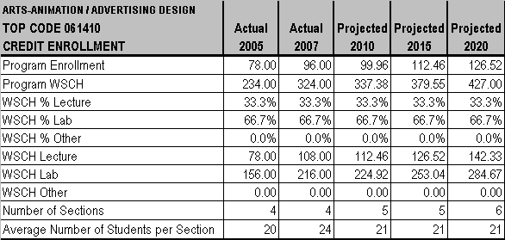
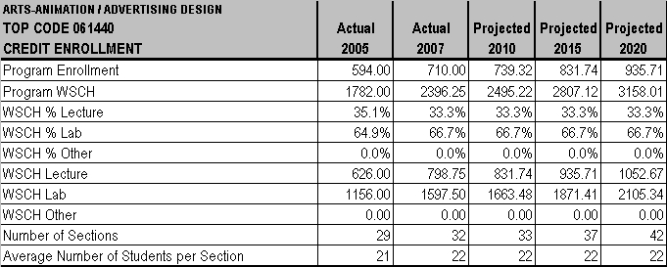
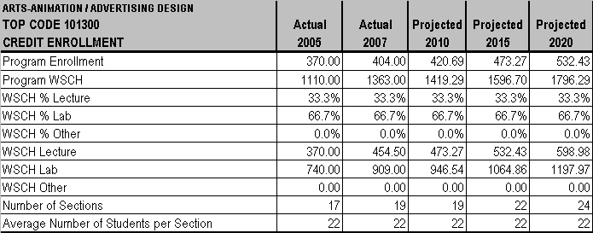

CHAPTER 3 - PROGRAMS AND SERVICES

MT. SAN ANTONIO COMMUNITY COLLEGE DISTRICT EDUCATIONAL MASTER PLAN - Page 120
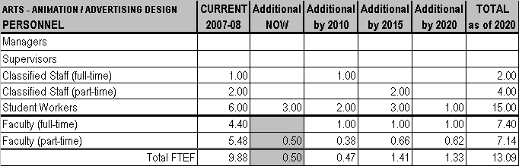

CHAPTER 3 - PROGRAMS AND SERVICES

MT. SAN ANTONIO COMMUNITY COLLEGE DISTRICT EDUCATIONAL MASTER PLAN - Page 121

CHAPTER 3 - PROGRAMS AND SERVICES

COMPUTER GRAPHICS
Neil Chapman, Chair
Joseph Ammirato, Computer Graphics

CURRENT PROGRAM
Computer Graphics responds to occupational needs. Plans for a transfer degree program in Applied Computer Graphics are in place.
ENROLLMENT
Class sizes in Computer Graphics range from 17 to 26 with the average class size being 20 for both lecture and lab. A waiting list for the Photo Editing Photoshop course is generally between 2 and 6.
FACILITIES
The Computer Graphics facility, currently one lab in Building 21, has been impacted by growth in the program. Twenty-five additional
computer systems, storage in Building 21, and a variety of infrastructure improvements (fiber optic gigabit network, photo quality classroom
projectors, gigabit network switches, classroom smart boards, audio amplifiers, and classroom network access wiring) are needed now.

TEACHING METHODOLOGIES
Computer Graphics teaching methods are split between lecture (40%) and lab (60%).

PERSONNEL
The Computer Graphics program currently employs 1.15 full-time and 1.55 part-time faculty (2.7 total) and a student worker. A full-time classified staff person is needed now.

FUTURE PLANS
In addition to plans for a transfer degree in Applied Computer Graphics (which are in place), Computer Graphics would also like to offer a
laboratory school. Although the Computer Graphics program is not new, the transfer degree would likely involve a name change and
revisions.
ENROLLMENT
Enrollments for Computer Graphics are expected to grow at a faster rate than the District between now and 2015. Factors affecting growth and future plans through 2020 include computer technology and software advances, an increased reliance on “smart” systems (SSRLNASA), and increased competition in the marketplace.
FACILITIES
Computer Graphics needs a 25-seat lab and additional storage in Building 21 and a backlot on campus by 2010. Between now and 2020, there also will be on-going needs for additional computer systems and infrastructure improvements including classroom network access wiring by 2015 and gigabit network switches by 2015 and again by 2020. The addition of a backlot and laboratory school will also require additional facilities and technology.

TEACHING METHODOLOGIES
Computer Graphics anticipates the future inclusion of teaching labs in a laboratory school will change the teaching methodologies to lecture (15%), lab (25%), teaching labs/laboratory school (60%).

PERSONNEL
Computer Graphics anticipates increasing staff with .5 part-time faculty member by 2010, 1 full-time faculty and 1 half-time (.5) classified staff person by 2015, and a .5 part-time faculty member by 2020.

MT. SAN ANTONIO COMMUNITY COLLEGE DISTRICT EDUCATIONAL MASTER PLAN - Page 122
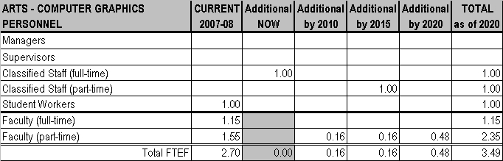
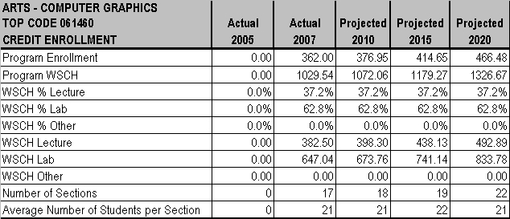
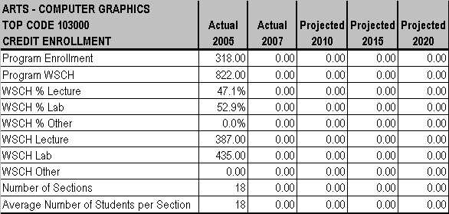

CHAPTER 3 - PROGRAMS AND SERVICES

MT. SAN ANTONIO COMMUNITY COLLEGE DISTRICT EDUCATIONAL MASTER PLAN - Page 123

CHAPTER 3 - PROGRAMS AND SERVICES

MUSIC
Sue Long, Dean
Jason Chevalier, Chair

CURRENT PROGRAM
The Music Department serves transfer and some general interest needs (beginning piano and voice) of students. A major in Music degree was just approved.

ENROLLMENT
Between 2005 and 2007, Department enrollment increased 4% (WSCH 18%), and the number of sections increased 2%, indicating that the Department increased its efficiency while increasing the number of class offerings. Average class sizes are 35 in lecture and 20 in lab. Performance ensemble classes range in size from 5 to 65 students, theory classes range in size from 20 to 30 students, and general education classes serve between 35 and 42 students. Typically there are waiting lists of between 5 and 10 students for the following
classes: Music Appreciation, History of Rock, and History of Jazz.
FACILITIES
The Department currently uses the following facilities in 2M: offices and practice rooms, classrooms, a rehearsal room and a green room. The offices, practice rooms and green room need new carpet, one classroom needs a projector/computer, and the rehearsal room needs audio/visual equipment.
TEACHING METHODOLOGIES
Teaching methods include lecture (30%), lab (30%) and lecture/lab combinations, such as Music Theory (40%).

PERSONNEL
At this time Music employs 7 full-time and 12 part-time faculty, a full-time administrative assistant and a student worker. The Department needs 3 additional full-time faculty and an additional student worker at this time.

FUTURE PLANS
The Music Department would like to start an orchestra to help capture students from high schools in the area that have orchestras, and would like to expand technology offerings to develop a pop/commercial music program to meet the needs of less traditional students who are not currently served by the department.
ENROLLMENT
Enrollments are expected to grow at the same rate as overall District enrollment between now and 2020. The new Music Bridge learning community, designed to support Basic Skills, is designed to increase student levels of retention and success, and should add more students to theory classes and performance ensembles.
FACILITIES
The program needs the following additional facilities in the Performing Arts Center or adjacent location: a lecture classroom by 2010, a recording studio by 2015 and a music technology center by 2015.

TEACHING METHODOLOGIES
No changes in teaching methodologies are planned, although there is a potential by 2020 to add a Distance Education component to some classes, such as History of Rock, History of Jazz, and Music Appreciation.

PERSONNEL
By 2010 the Department will need an additional full-time classified staff member and an additional part-time faculty member. By 2015, 2 more full-time faculty and another student worker will be needed, and by 2020 2 additional full-time faculty will be required.

MT. SAN ANTONIO COMMUNITY COLLEGE DISTRICT EDUCATIONAL MASTER PLAN - Page 124
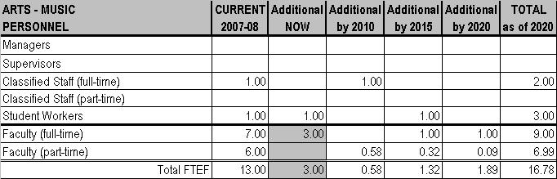
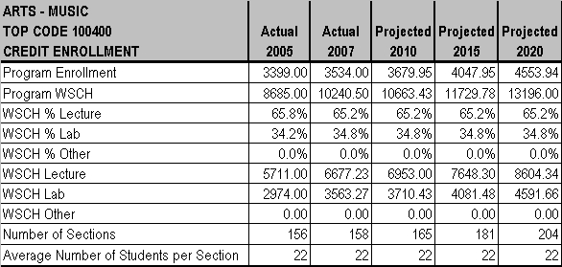

CHAPTER 3 - PROGRAMS AND SERVICES

MT. SAN ANTONIO COMMUNITY COLLEGE DISTRICT EDUCATIONAL MASTER PLAN - Page 125

CHAPTER 3 - PROGRAMS AND SERVICES

PHOTOGRAPHY
Neil Chapman, Chair

CURRENT PROGRAM
The Photography program serves transfer, occupational, and general interest needs. Establishment of a Digital Editing Photo Assistant certificate is in progress.
ENROLLMENT
Enrollment in the Photography program has dropped approximately 20%, but this is attributed to moving temporarily to a location that is
nearly half the former size. Once a new facility is completed, enrollment is expected to return to original size or perhaps even increase.
Class sizes range from 16 to 20 with the average class size being 18 for both lecture and lab. Typically there are waiting lists of between
30 and 50 students for the 8 sections offered for Beginning Photography and between 5 and 10 students for the one section of Color Photography.

FACILITIES
A plan is in place to build a new facility for the Photography program, but it is currently in a temporary facility which is 40% smaller than the
former location. Two classrooms only have capacity for 16 and the studio is too small for shooting and lacks adequate storage space. The
studio also lacks a prop room and computer room. Additional current needs are computers, software, and digital studio photography
equipment.

TEACHING METHODOLOGIES
Primary teaching methods for Photography include lecture (35%), lab (55%), and other (10%) which includes demonstration and field assignments.

PERSONNEL
The Photography program currently employs 2.85 full-time and 2.75 part-time faculty (5.60 total), a full-time and a half-time classified staff, and 1 student worker.

FUTURE PLANS
The completion of the new and larger Photography facility - with increased room capacity and number of course offerings -- is expected to favorably impact program enrollment. Photography is beginning to develop a strategy to serve students pursuing a goal of fine art
photography and is considering a laboratory school. Growth in the field of photography in general will also be affected by technology
changes (such as computer generated imagery, digital equipment, and elimination of chemicals).
ENROLLMENT
Once moved into the new facility, the Photography program expects to fully recover from the current drop in enrollment and grow faster than overall District enrollment between now and 2010, then grow at the same rate as the District through 2020.
FACILITIES
Photography needs digital studio photography equipment now through 2010. Computers and software are an ongoing need through 2020. The program needs a permanent facility but a specific timeframe has not been established.

TEACHING METHODOLOGIES
A Photography laboratory school that connects student teams with “real world” experiences would shift the teaching methodologies utilized to lecture (30%), lab (40%) and laboratory school (20%).

PERSONNEL
By 2020, the Photography Department will need to increase full-time faculty from 2.85 to 3.85 (adding one by 2020); part-time faculty from
2.75 to 4.75 (adding .5 by 2010, 1 by 2015, and .5 in 2020); full-time classified staff from 1 to 2 by 2015; and student workers from 1 to 3 (by adding one by 2015 and another by 2020). The half-time classified staff position will remain constant through 2020.

MT. SAN ANTONIO COMMUNITY COLLEGE DISTRICT EDUCATIONAL MASTER PLAN - Page 126
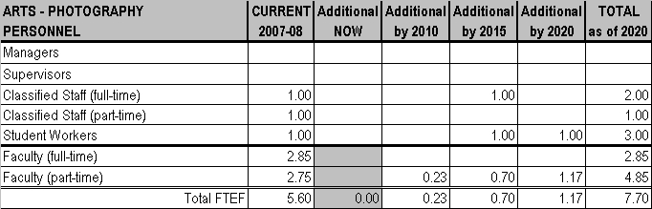
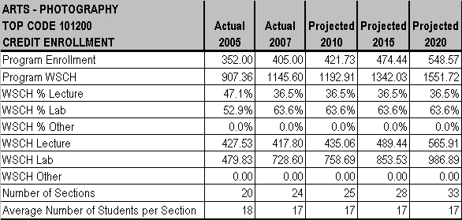

CHAPTER 3 - PROGRAMS AND SERVICES

MT. SAN ANTONIO COMMUNITY COLLEGE DISTRICT EDUCATIONAL MASTER PLAN - Page 127

CHAPTER 3 - PROGRAMS AND SERVICES

RADIO AND TELEVISION
Sue Long, Dean
Daniel Smith
Tammy Trujillo

CURRENT PROGRAM
The Radio and Television Department meets the transfer, occupational, general interest and general education needs of students. The
program has adequate funding; however, there has not been a commensurate growth in classroom and lab space or equipment which is
critically affecting the program. For example, television equipment must be shuttled from place to place on a daily basis in order to re-wire
and serve lectures. This takes up much of the faculty’s time, and hampers the ability of students to finish their coursework and the
program.
ENROLLMENT
Enrollment growth in lecture sections is now averaging 15% each year, while that of lab sections is increasing at a rate of 58% annually.
Class sizes range from 15 to 35 with an average of 20 students for lecture classes and 25 students for labs (although the lab area only has
space for 10 students). The recorded waiting list sizes range from 2 (for Beginning and Advanced Television Production classes) to 9
students (for Writing for Television and Film and Editing for Television and Film). However, waiting lists do not reflect all students who
would like to add classes, but know space is not available. A more accurate figure would be waiting lists ranging from 20 to 25 students for
each of six classes.
FACILITIES
Program space should be contiguous, because of the nature of the program and to promote cross-disciplinary learning. Instead, the
program is currently out of space and has been forced to move a number of classes to a remote building, but this has not been an
adequate solution. There is not enough equipment and space to serve the existing enrollment. The current facilities were not designed for
TV or Radio instruction, which has created a variety of deficiencies: insufficient space for students and equipment, classrooms shared with
other programs and their equipment, bad sightlines, etc. The television studio, for example, is unclean, has no desks or Internet access,
has limited ADA access and functionality, and doubles as storage space. Equipment purchased two years ago cannot be used because
there is no space to set it up. Currently, 42 radio production students share three computers, while 75 TV production students share ten
computers. These computers are housed in space shared for lab and lecture instruction. A 35-seat classroom and 25-seat edit bay are
needed now in Building 6, along with 10 high definition video cameras with disk recording capability and 10 high definition video uploading
units.
TEACHING METHODOLOGIES
Teaching methods include lecture (60%) and lab (40%).

PERSONNEL
The Department has 2 full-time and 1.25 part-time faculty instructors, as well as 1 full-time classified staff person (the head of the radio
station) and 4 student workers. One additional half-time faculty member and a 19-hour per week classified staff person are needed now.

FUTURE PLANS
New curriculum in the near future will include On-Camera Performance and the integration of aesthetics training into the foundation of the TV program. Media instruction will be increasingly interdisciplinary, allowing initiatives into Broadcast Journalism and new media to
continue. High demand in the industry for interns and technicians opens the door for additional program expansion opportunities also. A media aesthetic course (RTV 14) is being added.

ENROLLMENT
Enrollments are expected to grow faster than overall District enrollment each year between now and 2020. The program will likely grow to a size commensurate with the high demand from the surrounding areas. There are 240,000 entertainment media jobs in the Los Angeles area alone and corporate media is a $12 billion industry nationally. A variety of new media in the historically recession-proof entertainment media will increase growth even more quickly. This will create completely new job titles, as well as demand for instruction to train skilled personnel in the areas of HDTV, HD Radio, editing for DVD, mobile entertainment, and more.

MT. SAN ANTONIO COMMUNITY COLLEGE DISTRICT EDUCATIONAL MASTER PLAN - Page 128
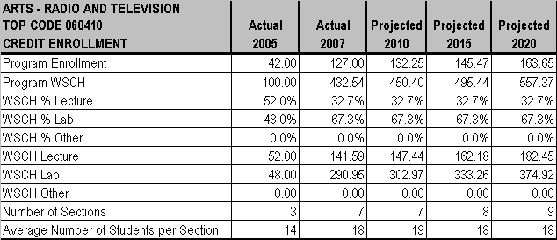
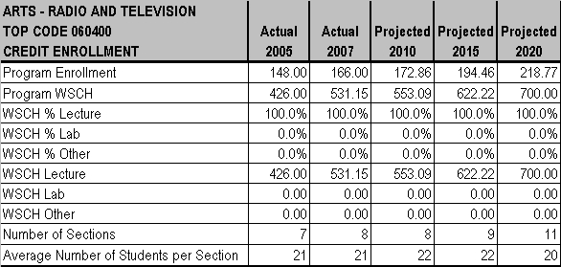

CHAPTER 3 - PROGRAMS AND SERVICES

FACILITIES
By 2010, a TV production lab with storage needs to be included in the Design Technology Center and two radio production labs will be
needed in Building 6. A radio production lab, a radio classroom with studio, and one large office for part-time faculty and staff will be
needed by 2015 in Building 6. By 2020, classrooms seating 35 will be needed in the Design Technology Center. Replacement cycle
computers, HD video cameras, video editing computers, related software, and a server for the edit bay will be needed by 2010. By 2015,
30 video editing computers and related software will need to be replaced again, and a server for a second edit bay is needed.

TEACHING METHODOLOGIES
There are many opportunities for intern activity, so teaching methodologies are anticipated to shift to lecture (60%), lab (35%), and work experience (5%).

PERSONNEL
There needs to be more hands-on instruction, which is hampered by the current lack of space and computer resources. Future personnel needs include 1 part-time faculty instructor and a 19-hour per week computer technician by 2010; a full-time FTEF and 1 student worker by 2015; and a half-time FTEF and 1 full-time classified employee by 2020.

MT. SAN ANTONIO COMMUNITY COLLEGE DISTRICT EDUCATIONAL MASTER PLAN - Page 129
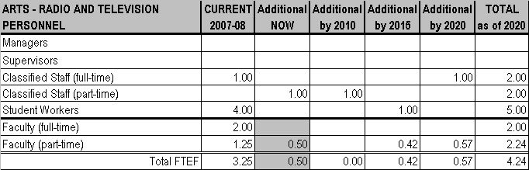
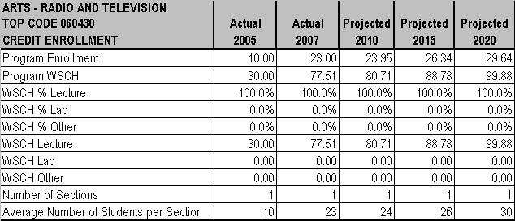
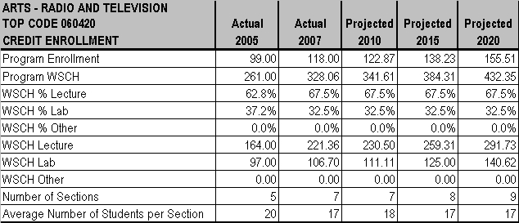

CHAPTER 3 - PROGRAMS AND SERVICES

MT. SAN ANTONIO COMMUNITY COLLEGE DISTRICT EDUCATIONAL MASTER PLAN - Page 130

CHAPTER 3 - PROGRAMS AND SERVICES

STUDIO ART
Michael Falzone, Co-Chair

CURRENT PROGRAM
Studio Art serves the transfer, occupational and general interest needs of students. While all aspects of the Department encourage innovation and experimentation, it is recognized that these come from a foundation of advanced skills and time-proven techniques generated by and through the core curriculum.
ENROLLMENT
Class sizes currently range from 20 to 25 students. The average size of lab classes is 20 to 25 students; lecture class average size is also
20 to 25 students, but could be 35 students if classroom space were larger. Advanced courses that are “stacked” with similar courses (and
taught by the same instructor in the same classroom) vary in size from 1 to 16 students. All classes except ARTD 21, ARTS 42 and 46,
and ARTG 20, 21, and 22 currently have waiting lists ranging from 1 to 12 students per section. The largest single waiting list is for
Ceramics with a total of 55 to 60 students waiting for all sections, averaging 8 to 10 students per section. Printmaking (TOP Code 100300)
was not offered in Fall of 2007 due to the conversion of the space to a temporary computer lab for another program, but will be offered
again in the Fall of 2008.
FACILITIES
The Studio Art Department is currently housed in a complex of buildings open 7 days each week. The 1B complex consists of three
buildings which were renovated during the past four years, but growth necessitates additional space appropriation. The 1A building, built in 1972, houses specialized studios and shares space with other disciplines. This building was originally designed to hold a second story, but the installation of cellular towers has eliminated this option to create the additional facilities needed. The immediate needs for the
department are a workroom (for Drawing), dedicated spaces for both Printmaking and Ceramics, storage in the Gallery, a lecture
classroom, and equipment to facilitate hands-on experience with technology advances. Environmental issues regarding lack of proper ventilation also need to be addressed now. Not enough classroom space and deficient facilities are restricting the number of classes that the department would like to offer to meet demand, does not allow provisions for “open lab” use by students which is required to complete course requirements, and has created health concerns for students and instructors from inadequate ventilation.
TEACHING METHODOLOGIES
Only one course offered (ARTB 1) uses lecture methodology exclusively; all studio classes use a combination of lecture (33.3%) and lab (66.7%) methodology.
PERSONNEL
At this time the program employs 12.3 full-time and 23.8 part-time faculty members; 2 full-time and 1 part-time classified staff, and 2
student workers. The immediate needs are for 1.2 full-time and .8 part-time faculty members, 1 part-time classified staff person and 4 student workers. The need for secretarial assistance is a priority: in addition to teaching and research responsibilities, faculty members have assumed a variety of secretarial tasks due to a shortage of classified personnel. This has created stress within the faculty, especially for senior members, and is reducing time for classroom activities and student development.

FUTURE PLANS
Growth for this area is anticipated to be directed toward Two-Dimensional Design, Drawing/Life Drawing and Painting, Printmaking, ThreeDimensional Design and Sculpture, Ceramics, and gallery programs. Contributing to this potential growth are changes in pre-requisite requirements in the newly created Commercial and Entertainment Arts Department, as well as industry demands including the development of “green” methods of printmaking and a hiring shift away from designers with technology-only skills to employees who are both
computer and art Savvy. Cultural growth in society and the desire to retain hand-crafted objects in a time of technological growth also are factors. To prepare for these potential growth areas, the following new programs are being planned and/or discussed:
• Life/figure painting for both fine art and commercial application
• Beginning drawing courses designed for specific groups of students: fine art, general education, etc.
• Adding a second section of ANIM 101 drawing course in winter intercession or spring
• Reinstating the Figure-in-Motion drawing course originally created for the Animation program
• Digital (computer) printmaking integrated with traditional printmaking techniques
• An advanced Ceramics course addressing the vessel as a sculptural object
• Reinstating the Jewelry/Metals courses after the Commercial and Entertainment Arts Dept. move in 2010.

MT. SAN ANTONIO COMMUNITY COLLEGE DISTRICT EDUCATIONAL MASTER PLAN - Page 131
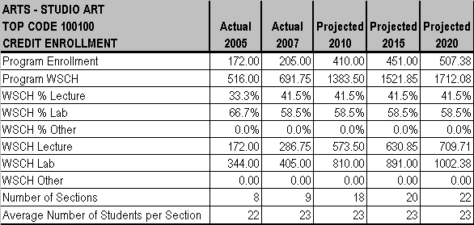

CHAPTER 3 - PROGRAMS AND SERVICES

ENROLLMENT
ARTtB 1 will double in size in 2009 and lead to faster growth than the rest of the college in 2010, but then the Department is anticipated to grow at the same rate as the overall District in 2015 and 2020. Due to new pre-requisite changes in the Animation, Photography and
Graphic Design programs, growth of 15% to 200% in 2010 is expected for the Two-Dimensional Design classes as four new sections will be offered that year, and up to eight new class sections are envisioned by 2016. The Drawing and Life Drawing areas anticipate 10% to 30% growth in 2015. Enrollments in all other sections are expected to grow at the same rate as the overall District.
FACILITIES
Three rooms will be freed up for Studio Arts use when the Commercial and Entertainment Department moves into a newly constructed
building in 2010, but there will still be a need for additional space and equipment. In addition to general classrooms and shop/storage
areas, space designed and adequately equipped for specific purposes are needed in 2010, 2015, and 2020 (e.g.: a room dedicated for Life Drawing and hands-on studio space).
TEACHING METHODOLOGIES
No changes are expected except for Sculpture/3-D Design which anticipates redistributing teaching methodologies to 50% lecture and
50% lab.
PERSONNEL
By 2010 the Department will need 5.2 additional full-time (which includes the replacement hiring of a retiring full-time professor) and 4 parttime FTEF members plus 3 part-time classified staff persons and 2 student workers. These figures include an IET technician to help with computer issues for two Studio Arts classrooms when space currently used for Animation and Graphic Design computer courses are
moved to a new building. By 2015 another 3.4 full-time and 4 part-time faculty members, 1 part-time classified staff and 2 student workers will be needed, and by 2020 5.8 new full-time and 6.4 part-time faculty members, 2 full-time classified personnel and 1 student worker will be needed to meet anticipated growth. Hiring a second full-time professor for Two-Dimensional Design will be a priority in the future as current history has shown difficulty finding qualified instructors for these classes.

MT. SAN ANTONIO COMMUNITY COLLEGE DISTRICT EDUCATIONAL MASTER PLAN - Page 132
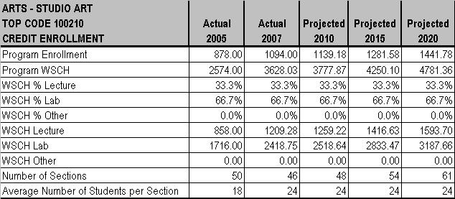
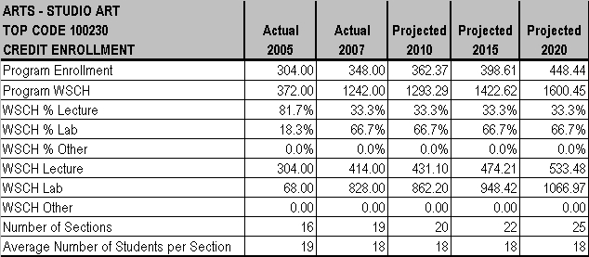
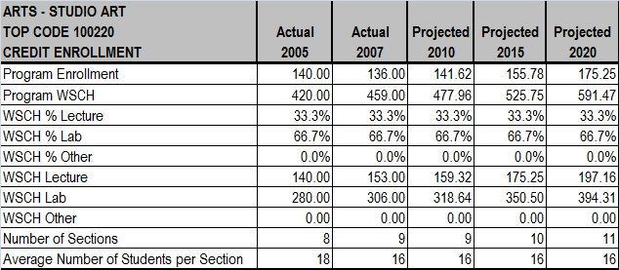

CHAPTER 3 - PROGRAMS AND SERVICES

MT. SAN ANTONIO COMMUNITY COLLEGE DISTRICT EDUCATIONAL MASTER PLAN - Page 133
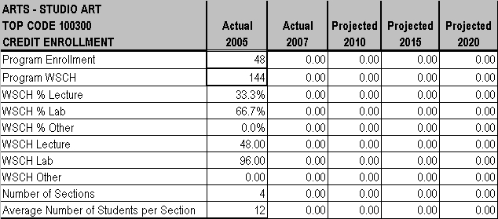
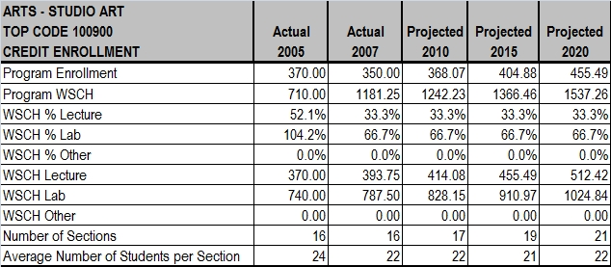
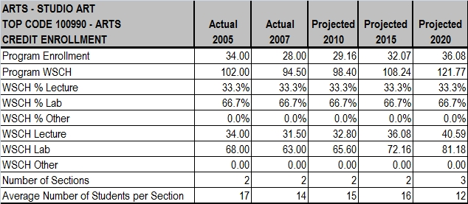

CHAPTER 3 - PROGRAMS AND SERVICES

MT. SAN ANTONIO COMMUNITY COLLEGE DISTRICT EDUCATIONAL MASTER PLAN - Page 134
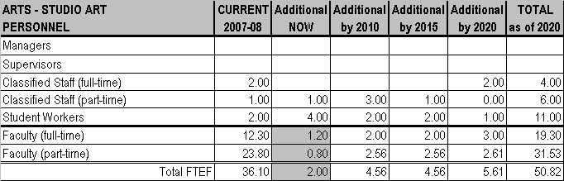
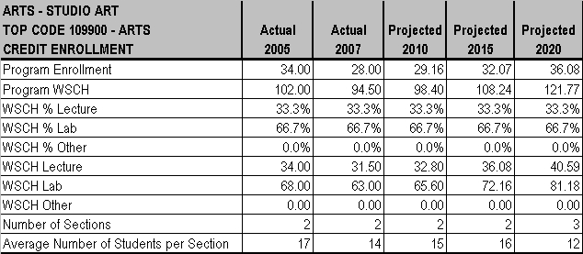

CHAPTER 3 - PROGRAMS AND SERVICES

MT. SAN ANTONIO COMMUNITY COLLEGE DISTRICT EDUCATIONAL MASTER PLAN - Page 135

CHAPTER 3 - PROGRAMS AND SERVICES

THEATRE
Sue Long, Dean
Gary Davis, Chair

CURRENT PROGRAM
The Theatre Department serves the transfer, occupational and general interest needs of students. While the current College Catalog says there is “no formal program,” such is not the case.

ENROLLMENT
Class sizes range from 12 students (for Children’s Theatre) to 50 students (for lecture courses). The average class size is 20 students for lectures and 16 students for lab. There are no waiting lists for classes at this time.

FACILITIES
In Building 2, the classroom has no rehearsal space and the Studio Theatre (which is also used as a classroom for some courses) has no lobby. There is no rehearsal space, the tech booth is too small, and the lighting facilities are insufficient and unsafe. Also located in
Building 2, the Clarke Theater has no property storage, insufficient scenery storage, and no Theatre Department Green Room. Current
needs in Building 2 are for a rehearsal room and storage for props and scenery, which requires renovation of the space. In the Studio
Theater, there is space to expand, and a tech booth, lobby, and tension grid are needed now. Other current needs include a 2-seat pickup truck to transport the Children’s Theatre Troop to schools and to transport items from Building 2 to a warehouse; 4 Verilights and a
controller; a digital sound board and 4 speaker clusters plus subwoofer for Studio Theater; a camera and CD player for Acting 4 TV class; and 6 regular and 1 industrial sewing machines.

TEACHING METHODOLOGIES
Classes use lecture (85%) and lab (15%) methodologies.

PERSONNEL
At this time the program employs 2.8 full-time faculty, 1.65 part-time faculty, 1 classified staff person (the Shop Foreman) who works fulltime for 10 months annually, 1 part-time (30%) classified staff person, and 1 student worker. Expanding the full-time Shop Foreman position to 12 months annually and adding a half-time (classified staff) costumer are the current needs.

FUTURE PLANS
Employment in technical theatre continues to be available at theme parks, TV and film studios, and theaters. In addition, no other program
in the community offers an intensive program in playwriting. With this in mind, the program plans to expand the Costume Certificate
Program by adding one course in Advanced Costuming and establishing a Playwriting program with full productions of student-written
short plays.
ENROLLMENT
Enrollments are expected to grow at the same rate as the overall District enrollment between now and 2020.

FACILITIES
A Theatre Department Green Room is needed in Building 2 by 2015.

TEACHING METHODOLOGIES
No change in teaching methodologies is anticipated.
PERSONNEL
By 2010, the program will need 1 additional full-time faculty member, 1 half-time faculty FTEF, and 1 student worker. A half-time classified staff employee and 1 student worker will be needed by 2015, and by 2020 an additional part-time faculty member, a half-time classified staff member, and a student worker will be required.

MT. SAN ANTONIO COMMUNITY COLLEGE DISTRICT EDUCATIONAL MASTER PLAN - Page 136
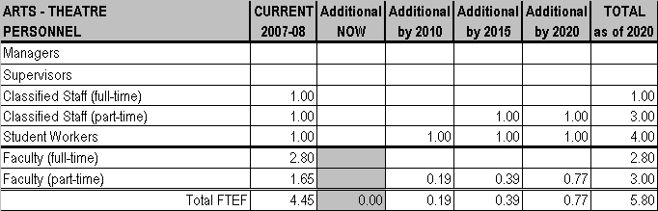
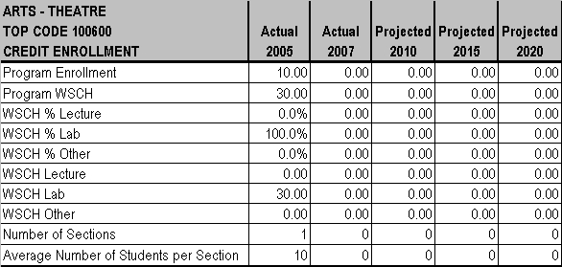
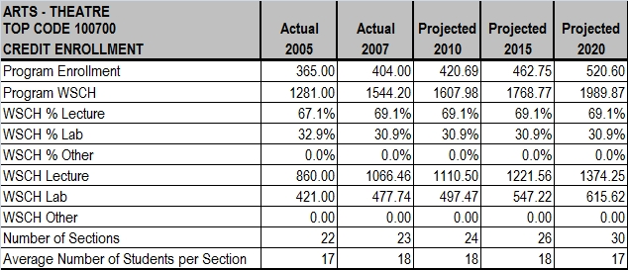

CHAPTER 3 - PROGRAMS AND SERVICES

MT. SAN ANTONIO COMMUNITY COLLEGE DISTRICT EDUCATIONAL MASTER PLAN - Page 137

CHAPTER 3 - PROGRAMS AND SERVICES

MT. SAN ANTONIO COMMUNITY COLLEGE DISTRICT EDUCATIONAL MASTER PLAN - Page 138

CHAPTER 3 - PROGRAMS AND SERVICES

